Krishna’s City. Re-discovery the Sunked Dwaraka

B
By Horacio Francisco Arganis Ph D.

Abstract
The discovery of Dwaraka was made by a group of specialists led by an eminent archaeologist S. R. Rao, from the governmental agencies of Marine Archeology and Oceanography of India and so was confirmed the finding of the legendary City founded by the great Prince of the Yadu Clan Vâsudeva- Krishna in the ending 80’s. But after almost more than 30 years of archeological research. the work on further excavation has met a formidable roadblock in the form of Jacobin academic sophistry and secular government apathy. A proposal submitted in the first decade 2000’s to the government by the late Dr S.R. Rao, was collecting dust for over four years. It is clear that for almost a decade, the Central India Government of those times, had not shown much interest in the excavations in Dwaraka. Therefore, the objective of this paper is to explorer the main causes of this negligence, exposing and unmask the main fraudulent sociological factors, that blocking this archeological discovery. Thereafter, to do a holistic and interdisciplinary review analysis on this sea unearthing. The author is open to reviews on the findings here, when hard irrefutable scientific proofs could be discovery in the future. But till today, the evidences show here, lead to holds a conclusions series in the end. Undoubtedly, the research presented here will try to answer some of the big questions on the subject of study. However, in turn, it will give rise to a series of unknowns questions, waiting that will be stimulate the scholars to investigate more and more.

In the ending 80's one breaking news went around the World. The press as TV news informed the discovery of the ancient city, Dwaraka submerged in the Arabian sea, in the state of Gujarata. The discovery was made by a group of specialists led by an eminent archaeologist S. R. Rao, from the governmental agencies of Marine Archeology and Oceanography of India and so was confirmed the finding of the legendary City founded by the great Prince of the Yadu Clan, and Avatara of God (Vishnu), Vâsudeva- Krishna ....
But after almost more than 30 years of archeological research, unlike Israel. where the Jewish government has invested and supported the great effort of its archeologists, when discovering its Traditional History, even Christian accounts, such as the findings of the Cana’s Wedding by Dr. Tom McCollough and His team in Khirbet Qana. Where, Archeologists had uncovered a large Christian veneration cave complex, that was used by Christian pilgrims who came to venerate the water-to-wine miracle. This complex was used beginning in the late fifth or early sixth century and continued to be used by pilgrims into the 12th-century around 900 years ago etc. This, as well known by all, is based on Biblical narrative. Also in the Arabian Peninsula, government agencies have given their support to the excavation of its traditional history, such like the archeological discovery of fabled lost city of Ubar, celebrated in both, the Holy Koran and "A Thousand and One Arabian Nights " as the center of the lucrative frankincense trade for 3,000 years before the birth of Christ, has been found by a Los Angeles-based team of amateur and professional archeologists. Using a combination of high-tech satellite imagery and old-fashioned literary detective work, they discovered the fortress city buried under the shifting sands of a section of Oman. Simply, all the Institutes of History and Anthropology receive great governmental support in all their respective countries, when investigating the legacy and historical cultural heritage of their own native cultures.
However, in the case of Dwaraka, the work on further excavation has met a formidable roadblock in the form of Jacobin academic sophistry and secular government apathy. A proposal submitted in the first decade 2000’s to the government by the late Dr S.R. Rao, was collecting dust for over four years. It is clear that for almost a decade, the Central India Government of those times, had not shown much interest in the excavations in Dwaraka or others in the Gulf of Khambat. Dr Rao is on record that Dwaraka excavation was carried out almost fully but the excavation in the inter-tidal zone of Balapur Bay in Bet Dwaraka where further antiquities may be found, has not been carried out partly due to the lack of funds and mainly due to lack of interest in the CSIR. Even though, Dwaraka, as today is still one of the best-studied underwater sites in India.
Therefore, the objective of this paper is to explorer the main causes of this negligence, exposing and unmask the main fraudulent sociological factors, that blocking this archeological discovery. Thereafter, to do a holistic and interdisciplinary review analysis on this sea unearthing. The author is open to reviews on the findings here, when hard irrefutable scientific proofs could be discovery in the future. But till today, the evidences show here, lead to holds a conclusions series in the end. Undoubtedly, the research presented here will try to answer some of the big questions on the subject of study. However, in turn, it will give rise to a series of unknowns questions, waiting that will be stimulate the scholars to investigate more and more.
Therefore, the follow themes are be display: 1 Operational definitions of Key words. 2 Methodology used. 3 Political environment around to this find. 4 Scientifics credentials of Dwaraka discovery. 5 Correlation of exploration site with the Krishna’s Dwaraka. 6, Dwaraka archeological Exploration. 7. What really happened to Dwaraka? 8. Discussion of Date problems.

- Operational definitions of Keys words
Abbreviation AD means After the Christian era and BC means Before the Christian era. This means before or after 2100 years that the Christian era began to be cuantify and lead the calendars of today's globalized world.

Alienation is a theoretical concept developed by Karl Marx that describes the isolating, dehumanizing, and disenchanting effects of working within a capitalist system of production. Here the term will be use like deliberate or unwilling transitory loss of reason or sense, especially because of an intense feeling of fear, anger, hater reactions when confronted with religious history demonstrations or a dissociative escape from reality when confront with scientific demonstration or discoveries that refute the paradigm that someone believes and defends with passion.

Communism: (from Latin communis, "common, universal") is a utopic, social, political, and economic ideology and movement whose ultimate goal is the establishment of the communist society, which is a socioeconomic order structured upon the common ownership of the means of production and the absence of social classes, money and the state.

Conservative Scholars. From Conservatism political and social ideology, that promote traditional social institutions, stressing the monarchy, Slavery, Feudalism, Colonialism, non-Religious freedom rights, racism, etc. in the context of culture and civilization. Here will be used to refer like those scholar defenders of the colonial model coming from the first orientalist imperialistic British Christians intellectuals.

Cynics: is an adjective applicable to the person who has an ironic or sarcastic attitude, typical of individuals who are interested in disguising their impudence. The characteristic of people who feel indifference or contempt for society, who have a dismissive behavior and ability to lie shamelessly. They even tend to hold falsehoods openly without any modesty or remorse.

Holistic: characterized by comprehension of the parts of something as intimately interconnected and explicable only by reference to the whole.

Hindutva: ("Hinduness") is the predominant form of Hindu nationalism in India. The term was popularized by Vinayak Damodar Savarkar in 1923. It is championed by the Hindu nationalist volunteer organization Rashtriya Swayamsevak Sangh (RSS), Vishva Hindu Parishad (VHP) and Hindu Sena, etc- Some left-leaning Indian social scientists have described the Hindutva movement as far-right, adhering to a disputed concept of Hindu homogenized majority and cultural hegemony.

Historical denialism or negationisms; is an illegitimate rejection of the historical record. It is exhibited by individuals who choose to deny reality in order to avoid an uncomfortable truth. It is the refusal to accept an empirically verifiable reality; It is in essence an irrational act that reject the validation of a historical experience or evidence".

Intellectuals Gunmen: Here will be used to refer a good hypercritical rhetorician who gets hired to write or speak against someone or something that is contrary to his employer who pays him or blindly advocate defender again facts and moral, to his party.

Intellectuals Mercenaries: These are good rhetorical people who serving merely for pay and sordid advantage, such people are venal also greedy. They are in the paid service of any ideological group or political party that hires them.

Jacobin. From French Jacobin (pronunciation iakovaen ) this term is associated with revolutionary and radical leftism. This meaning derives from the political action of the most extreme wing of the Jacobins during the French Revolution and, in particular, in the Terror’s years. Robespierre was the leader of this faction, in which militarized also: Danton, Marat, Desmoulins y Saint-Just, distingue by His radical atheism and pirronic bigotry. In the term will be used by to design the fundamentalist- bigotry atheistic, anti-religious intellectuals.

Jihadist Islamism: The term "Jihadism" (also "jihadist movement", "jihadi movement" and variants) is a 21st-century neologism found in Western languages to describe radical Islamist militant movements perceived as military movements "rooted in Islam" and "existentially threatening" to the West.

Marxism-Leninism: A social welfare travesty political doctrine, was the official tyrannical state ideology of the former Soviet Union, etc-

Modernistic: a practice, usage, or expression peculiar tendencies from Modernity times ideology from XIX, that violently rejected traditional forms so as to celebrate and incorporate into art the energy and dynamism of modern technology and naturalism ideology. A tendency (even in theology) to accommodate traditional religious teaching to contemporary naturalistic thought and especially to devalue supernatural elements

Misleading – misinformation: “false information that is spread, regardless of whether there is intent to mislead.” Disinformation, on the other hand, is defined as “deliberately misleading or biased information; manipulated narrative of facts like propaganda.”

Nationalist: a person who strongly identifies with their own nation and vigorously supports its interests, especially to the exclusion or detriment of the interests of other nations.

Neoliberal: ideology and policy model that emphasizes the value of free market competition. Both have their ideological roots in the classical liberalism of the 19th century, which championed economic laissez-faire and the freedom (or liberty) of individuals against the excessive power of government.

Organic Intellectuals, an intellectual member of a social class, as opposed to a member of the traditional intelligentsia. Here -It will be used to refer like to the unilateral thinkers that defend only His ideology or paradigm even before facts demonstrated scientifically.

Permissivism: Hyper-tolerant, uncritical permissive beliefs or attitude; lenience toward or indulgence of a wide variety of social behavior.

Political environment: is the state, government and its institutions and legislations and the public and private stakeholders who operate and interact with or influence the political system inside society in a Country.

Real Socialism: (also actually existing socialism was an ideological catchphrase popularized during the Brezhnev era in the Eastern Bloc countries and the Soviet Union. The term referred to the Soviet-type economic planning enforced by the ruling communist parties at that particular time.

Secular: denoting attitudes, activities, or other things that have no religious or spiritual basis. Or the extreme disassociation of Religious values and Cosmovisions in human life.

Secular religion is a communal belief system, based in political o philosophical ideology that often rejects or neglects the metaphysical aspects of the supernatural, commonly associated with traditional religion, instead placing typical religious qualities in earthly entities or ideas.

Scientism: Unlike the use of the scientific method as one mode of reaching knowledge, atheistic scientism claims that science alone is almost an omniscient deity that can render truth about the world and reality, even questions purely metaphysical and impossible to cover for the human being, as the “origin of the cosmos and what there is beyond”, until reaching the quality of omniscience, etc.

Sophistry and Sophism: comes from Greek sophistēs, meaning "wise man" or "expert", earned a negative connotation as "a captious or fallacious reasoner." Here will be use the term Sophistry like reasoning that seems plausible on a superficial level but is actually unsound, or reasoning that is used willingly to deceive.

2, Methodology
2.1 Archeology, like is a branch of anthropology science, should be holistic, It is based on, history, history of Art, classical studies, ethnology, geography, geology, history of literature, linguistics, semiology, textual criticism, physics, information science, chemistry, statistics based on anthropology, classical studies, ethnology, geography, geology, paleoecology, paleography, paleontology, paleozoology and paleobotany, paleoecology, paleography, etc. Scholars as Bahn, Paul, and Colin Renfrew, are explained this factor in Archaeology: Theories, Methods and Practice. New York, NY: Thames and Hudson, 2008 or Holistic Anthropology: Emergence and Convergence by David Parkin and Stanley Ulijaszek. Article in Journal of the Royal Anthropological Institute 16 (1):200-201 · January 2010, etc. Archeology imperative need of ethnography and history, because this scientific discipline cannot be alienate from all body o interdisciplinary evidence itself.

2.2 Ethnography: a scientific description of the culture of a society by someone who has lived in it, or a book containing this information type .

2.3 Documentary Historical evidence. This is defined as the origin of information, coming from write texts. In this case, whether it is the Sanskrit books of Hinduism and the texts of alternative dissident currents, even written in vernacular languages, Sanskrit commentaries, manuscripts, codices, letters, journals, logs and other documents such as newspapers, gazettes, the production of academic literature in general. According to their originality or order of precedence, they can be: Primary source, is the first-hand material related to a phenomenon that one want to investigate. In the case of historiography, the material that in its time has served to build history. Secondary source: is a text based on primary sources, which implies a treatment: generalization, analysis, synthesis, interpretation or evaluation. In historiography (the study of history), secondary sources are those documents that were not written contemporarily to the events studied. Tertiary source: it is a selection and collection of primary and secondary sources, for example: bibliographies, library catalogs, directories, reading lists and articles on surveys. Research works, textbooks, encyclopedias.

2.4 Historical geography: The geographic study of a place or region at a specific time or period in the past, or the study of geographic change in a place or region over a period of time.

2.5 Epigraphy. The study of written matter recorded on hard or durable material. The term is derived from the Classical Greek epigraphein (“to write upon, incise”) and epigraphē (“inscription”)

2.6 Other Method used was Calculations by computer simulation of Modeling climate-driven sea-level change, by ice melting and the Earth's response to mass redistribution movements within the sea.

2.7 Satellite Images: is Geological Survey with Remote Sensing, Aerial and satellite images, known as remotely sensed images, permit accurate mapping of land cover and make landscape features understandable on regional, continental, and even global scales.

2.8 Geology the fields of study concerned with the solid Earth. Included are sciences such as mineralogy, geodesy, and stratigraphy.

2.9 Archeoastronomy: is the branch of archaeology that deals with the a use, by pre and historic civilizations, of astronomical techniques to establish the seasons or the cycle of the year, especially as evidenced in the construction of megaliths and other ritual structures or astronomical references that appear in manuscripts.

2.10 Side-Scan Sonar as a Tool for Seafloor Imagery: The majority of the ocean world’s features are being discovered, identified, characterized and imaged by their interactions with sound, the use of acoustical geophysical devices that provide information about the seafloor and the strata below, transforming the things that we cannot see into numerical data and pictures which give us a model that is able to visually represent the seabed and to outline its physical proprieties and processes. This is a category of sonar system that is used to create an image of large areas of the seafloor. The system consists of a sonar device that is towed from a research vessel and emits fan-shaped pulses down towards the seafloor across a wide angle perpendicular to the path of a sensor.
2.11 Epistemology, (from the Greek πιστήμη --episteme, "knowledge", and λόγος (logos), "theory") stands out. It is a branch of philosophy whose object of study is limits and defects of scientific knowledge. Now it is revealing to be aware that among the scholars of these disciplines there is a whole discourse and debate with diverse opinions on the definition of what the sciences are. But in an operational way, the more general definition will be adopted as systematic and articulated type of knowledge that aims to formulate, through appropriate and rigorous languages, the laws that govern the phenomena related to a certain sector of reality. Set of objective facts accessible to several observers, in addition to being based on a criterion of truth, universality and a permanent correction, which leads to the generation of more objective knowledge in the form of concrete, quantitative observable facts and verifiable predictions referring to past, present and future. Although other classifications exist, Rudolf Carnap categorized them as formal sciences, natural sciences and social sciences.

2.12 The Social sciences, also called sciences of culture or spirit, are all the disciplines that deal with aspects of the human being - culture, art, spirituality and society, etc. The method depends on each particular discipline, even though all try to share objectivism and empiricism as a basis for verification. For example: anthropology - political science - demography - economics - law - history - psychology - sociology - human geography - social work, etc. In this paper we will be limited to presenting an epistemological analysis on a variation of these branches, the Indology, specifically the Archeological discovery of Dwaraka.

3 Political environment around Dwaraka discovery
Epistemology deals with problems such as historical, psychological and sociological circumstances that lead to the obtaining of a body of concepts about a certain field of study, and the criteria by which it is justified or invalidate. However in India, only some 70 years after its Independence, passing through that transition phase of struggle for its national identity, with changes in government and due to the reactive political environment that country is experiencing, these political factors have victimized some discoveries, such as Dwaraka. The subject is very deep and important today, would be nice to elucidated enough about this, but maybe it will be touch certain topics.
- On the one side there is the nationalist movement Hindutva, which has had different branches of activism whose political party is the Bharatiya Janata Party (BJP):
- On the other flank, It has different political opponents with their parties, some with a strong Marxist-Leninist tendency (Real socialism) that defend with passion this obsolete and unrealistic model.
- On yet another corner are also, the Nationalistic political parties of ideology "so called neoliberal" supposedly "secularizing" --- these parties believe upholding the Constitution of India being a “Sovereign Socialist Secular Democratic Republic” as its quintessential principle for its existence which precedes any individual, group, or political ideology”. But in reality are pro- Modernistic… Christianity sympathizers ---, who promote the permissive ideology of Occidentalism with all its hedonistic excesses and radical ideas, including Gender Ideology, atheist scientism and other excesses in the name of individual liberties or individualism.
- There are also others, radical groups, affiliates to Jihadist Islamism, whose have tried to appropriate States of India, such as Kashmir, etc.
- Besides these political parties, an additional incursion coming from Conservative scholars (Indian and Westerns), who viscerally reject any attempt to review to whoever that discover evidence or proposes new research that put in doubt or refutes their colonial paradigm— Aryan Invasion Theory (AIT) and the Müllerian dating model of Vedic texts— and agglomerate, to the liberal researchers, in the same cell as group (a -Hindutva)

3.1 All these political motive groups mutually are attacking between each and others, physically, morally and by means of misleading - disinformation, using their intellectuals mercenaries, along with a whole acculturation campaign to uproot the ancient culture and religion of India. In addition, all these groups use their religions or secular religious ideas like communism, Real socialism, atheistic scientism, etc., as a weapon of political activism, to the extent of committing communal violence among them, terrorist attacks with bombs, massacring one another: Christians, Muslims, Hindus, Marxist revolutionaries-Atheist militants, etc. And as it is done in every political ideology, they have waged great ruthless wars of misinformation and bitter rhetorical attacks by the mass media and intelectualoid-press to devastated the moral of Hinduism and the others opponents.
3.2 Since the Hindutva movement with the BJP, it has gained an influential position in the elections in Government of India and the party passionately defends the traditional religious history of this ancient culture and its great wise heroes such as Rama and Krishna, considered by its philosophical as a theological thought, God or Vishnu incarnated as human beings. So They (Rama and Krishna) have become the favorite target of BJP’s opponents rhetorical gunmen, with cynical tactics, as alienating as the historical denialism or negationims sophism.

3.3 So, the first archaeological excavations at Dwaraka were done by the Deccan College, Pune and the Department of Archaeology, Government of Gujarat, in 1963 under the direction of Dr. H.D. Sankalia. It revealed artifacts many centuries old, identifying with Krishna’s Yadava capital and later Dr. Rao lead the excavations in the 80’s. But after more than 40 years of official support, discoveries such as Dwaraka, which was considered "A hard proof in the last years to scientifically support traditional History”; this archeological succeeds have been victimized by all the above mentioned radioactive ideologies. And after 2004, the revenge came from those who came to power in those institutes of Oceanography and Archeology, even some of them were working in Dr. Rao’s team and now, like good mercenaries scholars, have try to rhetorically overshadow with bitters sophistry words tsunamis of Jacobin discourse, the finding of Dwaraka, under the excuse of secularism and " academic neutrality ".
3.4 In truth, the author would like to refute and debunk all those cynical tactics of sophistic argumentation from Jacobin- haters authors. Because, like any attempt to relativize and deny reality, it requires a lot rain of disinformative rhetoric. So, this paper shall not attempt an exhaustive treatment of the many of those fallacious arguments, since this would require a voluminous book. Rather, the author shall here make few a main points.

- In fact, objectivity and neutrality in scientific research is very important, and it is very harmful to use religion as a political weapon as Hindutva activists do. History has shown that using Science --- and more worse atheistic scientism--- as a political weapon has been more destructive. The horrors committed by the Scientists of Nazi Germany and Imperialism Nippon, with their enemy prisoners and political opponents are well known; and the use of the Atomic Bomb, in the WWII by the Allies against the innocent civilian population, equally the horrors in the communist countries together with their scientistic atheism, used in Psychiatry and Psychology, against their political and military opponents like the Reign of Terror, of Jacobin anti-clerical France 1793.

- In the end of 1991, the author remember as a distinguished Lady researcher in the Exact Sciences from the IPN of Mexico City, who is now a friend, but those days was a totally partisan and militant of Marxism-Leninism, openly told "that the Wall of Berlin in 1989, the Lenin Statue in Leningrad as the Socialist system, even the USSR, had never been collapsed and stopped existing; and that the photos, videos and all that news was "pure disinformation propaganda from Yankee Empire. And that the USSR still existed, with full Religion Freedom and Conscience and was the perfect Socialist Paradise”. Sadly, the poor woman suffered a pathetic case of Alienation and dissociation of the Historical Reality. Likewise, the Christian scholars of the Ideology of Borrowing reacted, towards all the archaeological as documentaries evidences which showed that Krishna lived and was worshiped long before Christ; and not that He was a derivative of Jesus (See Preciado1984). It is sad to say; but even today, there are advocates of the (AIT) and the Müllerian dating model of Vedic texts, which alienate and disassociate themselves from reality, before the archaeological evidence and discoveries that demonstrate the unreality of that model. Later will demonstrate the main flaws of this paradigm.

4. Scientifics credentials of Dwaraka discovery
4.1 Shikaripura Ranganatha Rao. (1 July 1922^{[1]} – 3 January 2013), commonly known as Dr. S. R. Rao, was an Indian archaeologist, who led the teams credited with the discovery of a number of Harappan sites including the port city Lothal . Parallely, Rao, with a commission of experts, using the Mahâbhârata as a map, rediscovered the City of Dwaraka, where Krishna lived in the Harbor of Gujarat, and by Historical Geography confirmed the existing cities in the area mentioned in the biographies of Krishna, even the Janma-bhumi in Mathura, U.P. In the First Indian Conference of Marin Archeology Jamnagar Gujarat 12 to 14 October 1987 conducted by the National Institute of Oceanography of Goa. Where Scientists from Indian and other nations attended, like Dr. Robert L. Kelly of USA, Dr. Flinder of International Society of Nautic Archeology, whose agrees with the scientific rigor achievements of Dwaraka finds. (Adwami et Raveendra 1988) In this regard, the specialist Andrew Rasanen, from Harvard University Center for the Study of Religions of the World, said:

…a compilation of archeological and textual data that summarizes the earliest recorded history of Vâsudeva Krishna. Although much of this historical information is available elsewhere in widely scattered form, it has no to my knowledge been brought together in so comprehensive and carefully researched a manner at it is here. Information on the recent excavations at Dwaraka in particular is a new addition to scholarly storehouse. (Rasanen in Rosen 1989: ix)

And the late Director of Indian National Institute of Oceanography, V. V. Varadachari stated: “This project is helping us to learn about our history, our culture, and our religion.” (Cit in Rosen, 1989:31). Y. S. Rawat , Director of the State Archaeology Department too, believes that a tsunami could well have led to the submergence of the ancient Dwaraka. "It is just that in the ancient times such sea activity was not known as tsunami. It is possible that large waves like that of a tsunami struck Dwaraka and drowned it," he says. "In fact, near the sea of today's Dwaraka, one can find remnants of Harappan culture during low tide." (Cit in Rao in STBM 2014)
It is relevant to remember, the first archaeological excavations at Dwaraka were done by the Deccan College, Pune and the Department of Archaeology, Government of Gujarat, in 1963 under the direction of Dr. H. D. Sankalia. It archaeological site revealed artifacts many centuries old. Later, over 12 expeditions were conducted in the period between 1983-1990, with funding for just 20 days in a year by Dr. Rao and his team, working off the coast of Dwaraka . Thus the UAW began excavations at Dwaraka again from January 2007. Alok Tripathi, Superintending Archaeologist, UAW ,said:
To study the antiquity of the site in a holistic manner, excavations are being conducted simultaneously both on land [close to the Dwarakadhish temple] and undersea so that finds from both the places can be co-related and analyzed scientifically." (Tripathi in Rao Opus cit)
4.2 In fact, the Discovery of Krishna’s Dwaraka appears in some Scientific Outreach documentaries on TV like Discovery Channel, Discovery Civilization, The History Channel, Scientific Verification of Vedic Knowledge Devavision, Sunked City of Dwaraka. Vision World Bengalore India 1988, etc., etc…
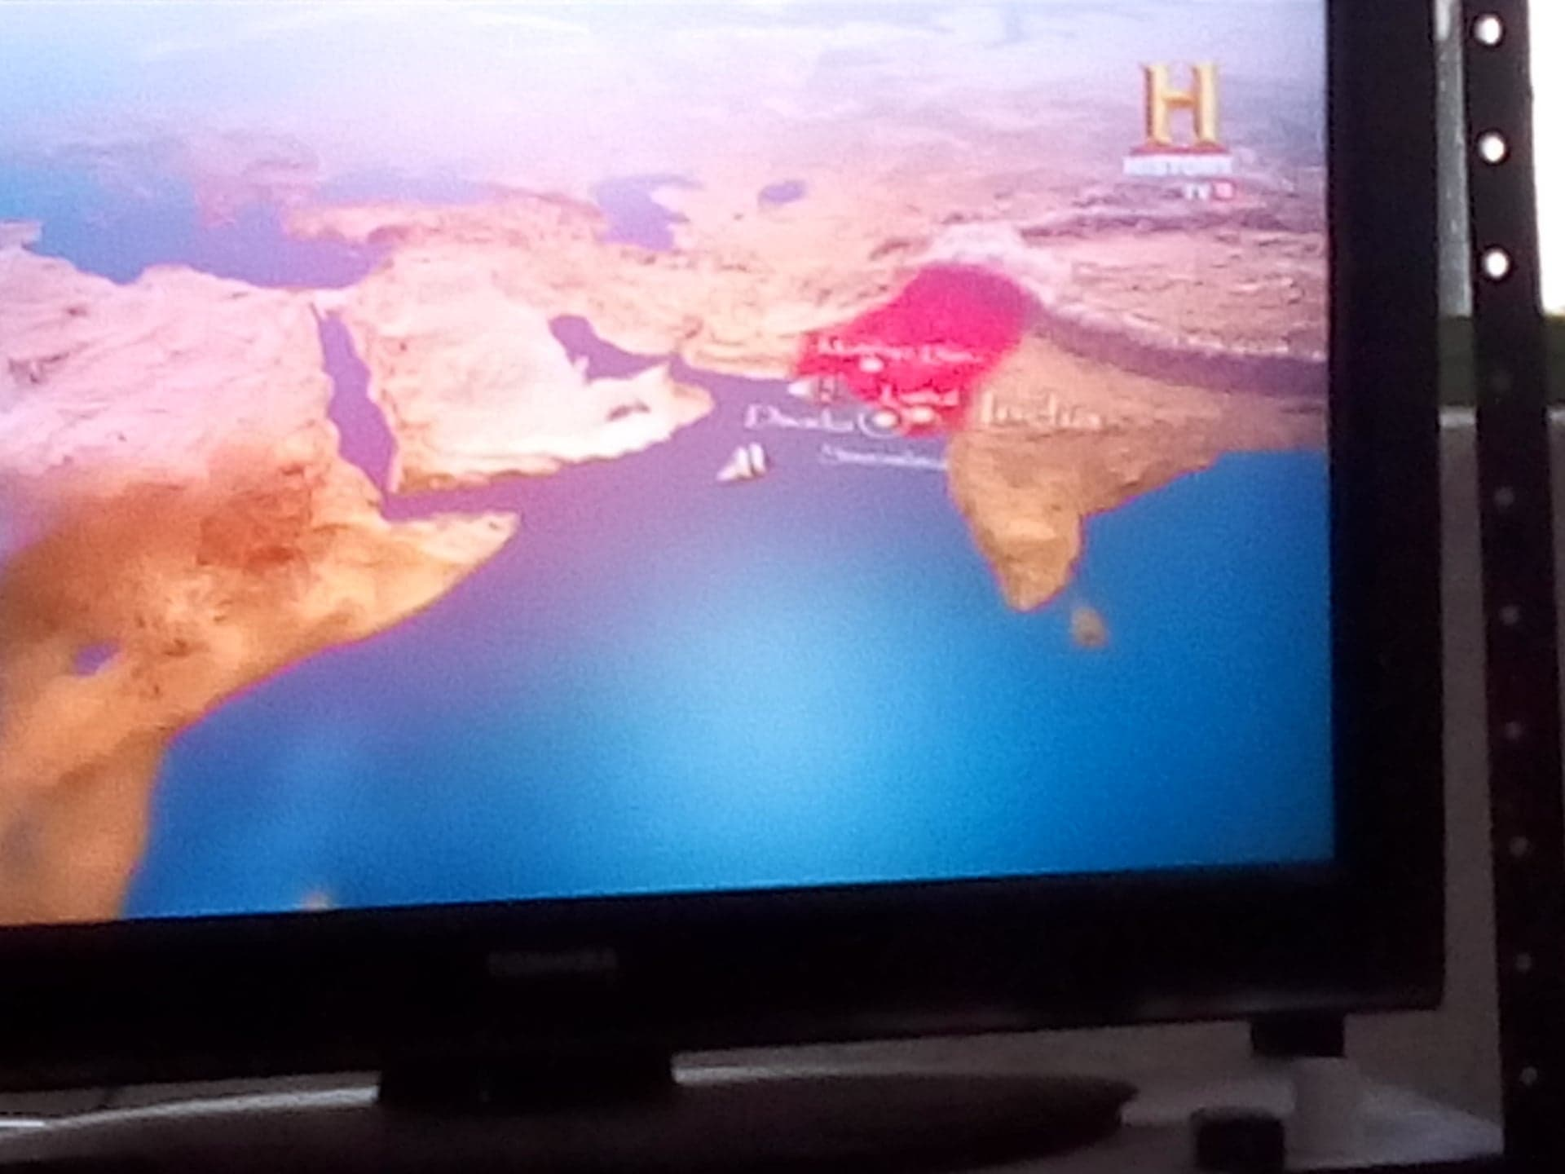

4.3 Enough said that in one of the top academic edited books, Vaisnavism. Cotemporary Scholars Discuss the Gaudiya Tradition, Ed. Rosen, Steven J. Folk Books, New York, 1992, where 25 Ph D scholars from the most prestigious Universities around the World participated, amongst them partake Dr. Edward C. Dimock. Chairman of the American Institute of Indian Studies, Dr. M. Witzchel, etc… The editor wrote in the Introduction: “Archeological historical researcher had indeed shed light on the tradition, as, for example, in the findings at Dwaraka and the textual analysis of the scriptures.” (Rosen,1992:1) Simply to end this part, Dr. Rao had published works of high academic level:
- Lothal and the Indus Civilisation, Bombay: Asia Publishing House, ISBN 0-210-22278-6 (1973)
- Lothal: A Harappan Port Town (1955 - 1962), Vols. I and II, Memoirs of the Archaeological Survey of India, no.78, New Delhi, ASIN: B0006E4EAC (1979 and 1985)
- Lothal, New Delhi: the Director General, Archaeological Survey of India (1985)
- Dawn and Devolution of the Indus Civilization, ISBN 81-85179-74-3, Delhi: Aditya Prakashan (1991)
- New Trends in Indian Art and Archaeology: S.R. Rao's 70th Birthday Felicitation Volumes, edited by B.U. Nayak and N.C. Ghosh, 2 vols. (1992)
- New Frontiers of Archaeology, Bombay: Popular Prakashan, ISBN 81-7154-689-7 (1994)
- The Lost City of Dwaraka, National Institute of Oceanography, ISBN 81-86471-48-0 (1999)
- Marine Archaeology in India, Delhi: Publications Division, ISBN 81-230-0785-X (2001)

5, Correlation of exploration site with the Krishna’s Dwaraka

5.1 Ethnographical evidence: In Oxford’s Doctoral researcher work by Samira Sheik, it is verified:

The descendants of Zafar Khan ruled Gujarat for the next century and a half and .... Princely state histories based on local documentation and clan genealogists ... The history and ethnography of Gujarat were among the chief interests of ...... genealogy of the Bhattis has a similar claim to Yadu or Yadava descent from Krishna. (Samira Sheikh, 2003)

Other Ethnographic research in 1916 by R. V. Russell reported:

The Yadus are a well-known historical clan. Colonel Tod says that the Yadu was the most illustrious of all the tribes of Ind, and became the patronymic of the descendants of Buddha, progenitor of the lunar (Indu) race. It is not clear, even according to legendary tradition, what, if any, connection the Yadus had with Buddha, but Krishna is held to have been a prince of this tribe and founded Dwarka in Gujarat with them, in which locality he is afterwards supposed to have been killed.
Colonel Tod states that the Yadu after the death of Krishna, and their expulsion from Dwarka and Delhi, the last stronghold of their power, retired by Multan across the Indus, founded Ghazni in Afghanistan, and peopled these countries even to Samarcand. Again driven back on the Indus they obtained possession of the Punjab and founded Salbhanpur. Thence expelled they retired across the Sutlej and Gara into the Indian deserts, where they founded Tannote, Derawal and Jaisalmer, the last in A.D. 1157 (around to 1000 years ago). ( Rusell 1916)

In fact, the ethnographical researchers has been discovery the same, for example Annals and Antiquities of Rajasthan; or the Central and Western Rajput States...– April, 1998, of James Tod & William Crooke, etc.

5.2 Documentary Historical evidence
5.2.1 In Sruti texts: According to some scholars, indications that the Vrisni dynasty is part of the Yadu clan, to which Krishna belonged and lived in Dwaraka, are found in the Taittiriya Samhita 3.2.93, Taittiriya Brahmana 3.10.9.15 and the Satapatha Brahmana 3.1.1.4. (Majumdar 1969: 268) Others authors find evidences that disclose the identity of Krishna in the Srutis, which refer to Radha, the principal gopi girlfriend of Krishna, in the following Samhitas: Vajasana 1.4.83, Katha 6.34, Taittiriya 3-10 and Madhyandina 3.9, (Sambidananda 1991): The epithet of Krsna-dhrti is adjective of Satyaki, the Yadava hero friend and relative of Krishna. (Idem). Later, there is another reference [1.6.1] that indicates the relation with Krishna in which the Vrisnis and Andhakas, Krishna's family stemming from the Yadava clan, are mentioned in the same text. Kausika Brahmana 30.9 also mentions Krishna in relation to the sage Angirasa. The Vajasaneyi Samhita 32.11 and the Satapatha Brahmana 2.1.5, 4 mention the appellation of Krishna as Gopala. The hagiographic puranic works use this name for Krishna in his boyhood activities in the company of the Gopas in Vrindavana.
The Vâsudeva Upanishad belongs to the Sama-Veda. It deals with Urdhva Pundra or the religious marks of Vaishnavas. Presented in the form of a conversation between sage Narada and Vishnu: There is said: Oh Achyutha who is staying in Dwaraka, Oh Govinda, Oh Lotus eyed one” (2).
In his classic Theological work, Krishna das Kaviraja, had show indications of Dwaraka (yadu-pura-saṅgamāya raṅgaṁ) and Ranga found in an old 16th century manuscript of Maho Upanisad. (CC. Madhya 24.24).

akleśāṁ kamala-bhuvaḥ praviśya goṣṭhīṁ,kurvantaḥ śruti-śirasāṁ śrutiṁ śruta-jñāḥ, uttuṅgaṁ yadu-pura-saṅgamāya raṅgaṁ, yogīndrāḥ pulaka-bhṛto navāpy avāpuḥ)
‘The nine Yogendras entered Brahmā’s association and heard from him the real meaning of the topmost Vedic literatures, the Upaniṣads. Although the Yogendras were already conversant in Vedic knowledge, they became very jubilant in Kṛṣṇa consciousness just by listening to Brahmā. Thus they wanted to enter Dvārakā, the abode of Lord Kṛṣṇa. In this way they finally achieved the place known as Raṅga-kṣetra.’

5.2.2 In the non –hindu opposites sources:
Is relevant, what inside of traditional Indian narrative and philosophy, till today, anybody has show, in the atheistic or agnostics doctrines like Charvakas, Vaisashikas, Ajivas, Nastikas Samkhya, Budhistic, Janis, etc…, a testimony again the identification of Gujarat Dwaraka like Krishna’s sunked City. The Buddhist texts like Gatajataka certify Dvaraka like Krishna ‘s city (Majumdar Op cit:23 ). The descriptions of Dwaraka in the The Jnatadharmakatha, which includes the Jain version of the Mahâbhârata. Another Jain works is the Harivamsa-purana of Jinasena (A.D. 783 around 1200 years ago) and the Jnata-dharma-katha mentions Dwaraka as large, well-fortified and prosperous due to sea trade this confirms that it was a port city. This is testimony of Jainas, whose oral record tradition dates back to the time of Krishna, they name a succession of thirtakaras sages, ranging from Risabha to Mahavira. G.V. Tagore states that these Jains, who are atheists, accepted Krishna as one of the nine Vâsudevas, a philosopher King and one of the master Thirtakaras (Tagare 1986). Ancient Jain literature corroborates Krishna by calling him Kanha. In the Jains oral tradition there are records relating the Shalakapurushas or notable personalities in history. Where Krishna is mentioned, his brother Balarama and the Jarasanda (the evil King who caused the immigration of Yadus dynasty, from Mathura to Dwaraka, by his 18 great army attacks). The references are also found in late Jains texts such as, the Trishashti-shalakapurusha-charita by the author Hemachandra.
Also others Buddhist works, like Kunala Jataka mentions Krishnaa (i.e., Draupadi) in addition to Bhimasena, Arjuna, Nakula, Sahadeva and Yudhittila (Pali for Yudhisthira). Dhananjaya of the Kuru clan (Arjuna) and Draupadi Svayamvara are referred to in Dhumakari Jataka. The same work refers also to Yudhisthira as an ancestor of the Kurus of Indapattana (i.e., Indraprastha) and also to Vidurapandita. In addition to these relatives of Krishna, Krishna himself is mentioned in Buddhist works such as Sutrapitaka and Lalitavistara. These works, Jaina and Buddhist, are often hostile to Krishna and his teachings, but the very fact they found it necessary to try to discredit him and his teachings, this proves that those are critical documentary historical literary evidence.

5.2.3 Purâna and itihasa testimony and its historical geography: Geographic study of a place or region at a specific time or period in the past, or the study of geographic change in a place or region over a period of time. The writings of Herodotus in the 5th century BC around to 2500 years ago, particularly his discussion of how the Nile River delta formed, probably provide an earliest example of what would be called historical geography in the West. According to historian S.M. Ali, the author of Geography of Purânas:

“The geographical matter contained in the Mahâbhârata is immense. It is perhaps the only great work which deals with geographic details and not incidentally, as other works.” (See Rao 1999)

In fact, any neutral researcher can see objectively, what puranic Dwaraka narrative is geographically very correct. Every site on Krishna's Dwaraka route is still identifiable and has continuing ethnological traditions or temples to commemorate Krishna's visit. Around 3000 years and more later 1000 years, no writer had the power and means to travel around the all India with an inventing tale, fitting it into local folklore and building temples for greater credibility. Because a task like that, till date would require a Super Rich -Sherlock Holmes Propaganda and Marketing Agency, to do a great detective’s and Marketing job, working with maps and places with a constant publicity persuasion campaign among people, as was done and is done in the communist countries by its mass media like TV. Look these examples of geographical descriptions:

SB 10.71.13 — O slayer of enemies, after He had arranged for the departure of His wives, children and baggage and taken leave of Lord Saṅkarṣaṇa and King Ugrasena, Lord Kṛṣṇa mounted His chariot, which had been brought by His driver. It flew a flag marked with the emblem of Garuḍa.
SB 10.71.14 — As the vibrations resounding from mṛdaṅgas, bherīs, kettledrums, conchshells and gomukhas filled the sky in all directions, Lord Kṛṣṇa set out on His journey. He was accompanied by the chief officers of His corps of chariots, elephants, infantry and cavalry and surrounded on all sides by His fierce personal guard.
SB 10.71.15 — Lord Acyuta’s faithful wives, along with their children, followed the Lord on golden palanquins carried by powerful men. The queens were adorned with fine clothing, ornaments, fragrant oils and flower garlands, and they were surrounded on all sides by soldiers carrying swords and shields in their hands.
SB 10.71.16 — On all sides proceeded finely adorned women-attendants of the royal household, as well as courtesans. They rode on palanquins and camels, bulls and buffalo, donkeys, mules, bullock carts and elephants. Their conveyances were fully loaded with grass tents, blankets, clothes and other items for the trip.
SB 10.71.17 — The Lord’s army boasted royal umbrellas, cāmara fans and huge flagpoles with waving banners. During the day the sun’s rays reflected brightly from the soldiers’ fine weapons, jewelry, helmets and armor. Thus Lord Kṛṣṇa’s army, noisy with shouts and clatter, appeared like an ocean stirring with agitated waves and timiṅgila fish...
SB 10.71.21 — As He traveled through the provinces of Ānarta, Sauvīra, Marudeśa and Vinaśana, Lord Hari crossed rivers and passed mountains, cities, villages, cow pastures and quarries.
SB 10.71.22 — After crossing the rivers Dṛṣadvatī and Sarasvatī, He passed through Pañcāla and Matsya and finally came to Indraprastha.

SB 1.10.34-35 O Śaunaka, the Lord then proceeded towards Kurujāṅgala, Pāñcālā, Śūrasenā, the land on the bank of the river Yamunā, Brahmāvarta, Kurukṣetra, Matsya, Sārasvata, the province of the desert and the land of scanty water. After crossing these provinces He gradually reached the Sauvīra and Ābhīra provinces, then, west of these, reached Dvārakā at last.
Tika: The provinces passed over by the Lord (Krishna) in those days were differently named, but the direction given is sufficient to indicate that He traveled through Delhi, Punjab, Rajasthan, Madhya Pradesh, Saurastra and Gujarat and at last reached His home province at Dvārakā. We do not gain any profit simply by researching the analogous provinces of those days up to now, but it appears that the desert of Rajasthan and the provinces of scanty water like Madhya Pradesh were present even five thousand years ago. The theory of soil experts that the desert developed in recent years is not supported by the statements of Bhāgavatam (Later paleontologists discovered evidence that this desert was a fertile plain only in Miocene. This data agrees with Bhâgavatam, that this desert existed in old times . See Arganis 2014: 76) . We may leave the matter for expert geologists to research…
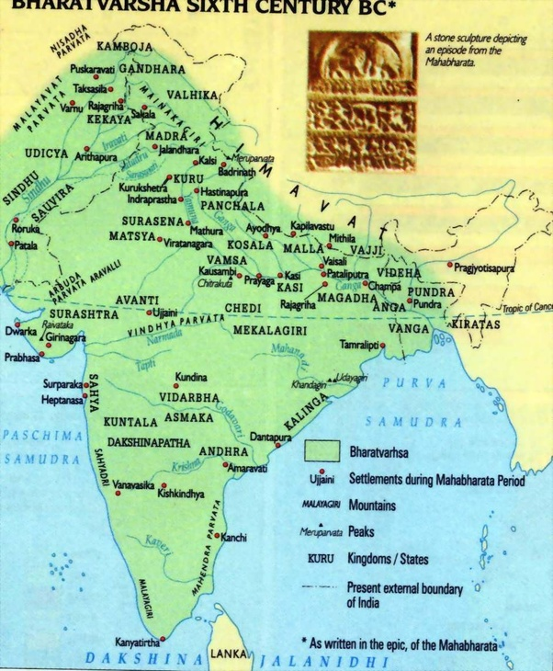
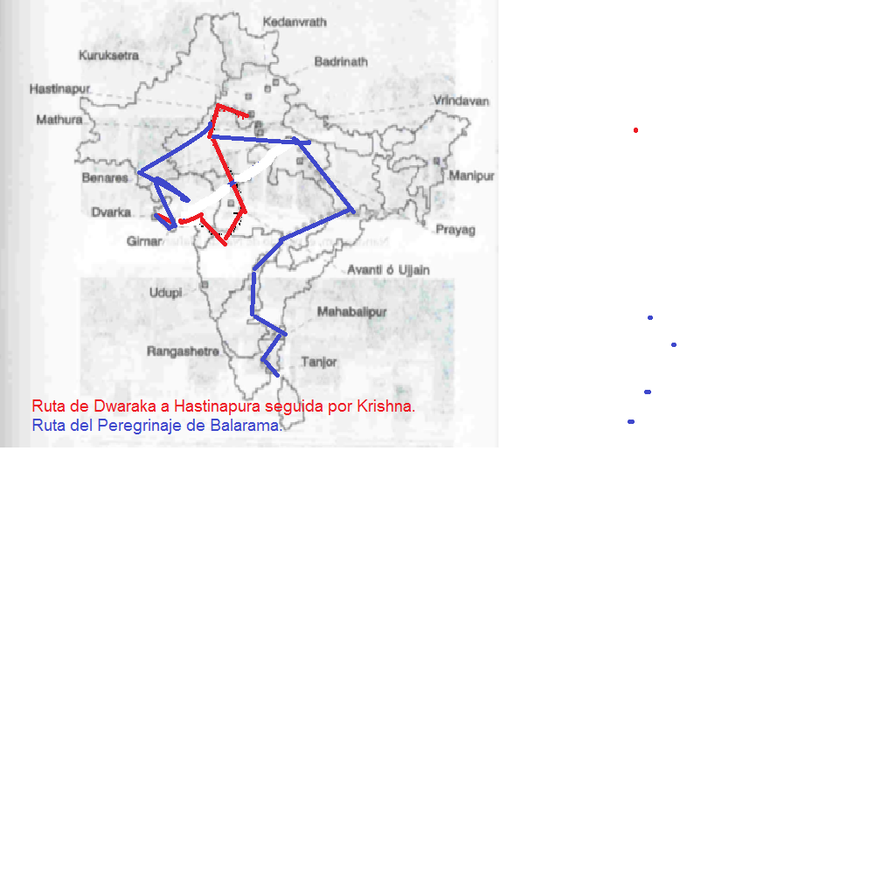

This metropolis is a coastal town in Jamnagar district of Gujarat. Traditionally, the ethnography and all body of traditional texts like puranic y Buddhist chronicles appoint, modern Dwaraka and its harbort with Dwaraka, mentioned in the Mahâbhârata as Krishna's city”. It is interesting, that all the historical geography mentioned in the writings of India, through all of the history, mention with precision the place of Dwaraka that was submerged in the bay of the present city. And there is not a single mention of another city in out of the state of Gujarat with that name Dwaraka like Krishna’s ancient city.
The Indian traditional history is replete with accounts of how the original Dwaraka looked like. Mahâbhârata poetically says that Dwaraka had 900,000 royal palaces, all constructed with crystal and silver and decorated with emeralds. The city was connected by an elaborate system of boulevards, roads, market places, assembly houses and temples. These legends have been etched into the Indian minds for so long that their authenticity is not questioned. Fortunately, due to the grace of the marine archaeological department of India, this epic history have come to be a reality to a great extent.
The reclamation of land from water-logged areas, referred to in Mahâbhârata, in order to build the city, is also attested by the boulder foundations over which walls and bastions were raised. The traditional records referring Dwaraka and its submergence as is referred to in the Mahâbhârata, Harivamsa, Matsya, Bhâgavatam and Vayu Puranas, etc.

5.2.4 Post-Smriti texts: Dwaraka had found a place in the grammar texts, for Panini, in his Ashtadhyayi refers to Cakragirti, which is identified with Cakratirtha at the mouth of the river Gomati where Dwaraka is situated. The durgavidhana and durganivesa prakaranas of the Arthasastra of Kautilya, Chanakya prescribe the layout of a city. It is also mention to Krishna and Kamsa, the birth history of Krishna, His family ancestors Vrishnis Dwaraka residents and vital events that lead to Yadu Clan and Dwaraka fall down, like Dvaipayana Vyasa curse, Balarama and devotees of Krishna with shaved head and tuft of hair (sikha).
Mahabhasya Grammar of Patanjali said: Krishna is not an ordinary king but the Venerable one, Krishna the enemy of Kamsa, Balarama, Janardana (Krishna), one temple of Balarama and Kesava (Krishna), and the others Dwaraka’s residents like Akrura the uncle, Svaphalka the granduncle, Ugrasena the grandfather, Vâsudeva, Balarama, Andhakas, Vrishnis. Nirukti of Yaska mention about Krishna and his Queens wives Jambavati and Satyabhama famous in Dwaraka accounts.

5. 2.5 In the old Tamil Sangam texts, speak of Dwaraka and people from Dwaraka that settling down in the South as part of the Chera lineage. The saints Alvars elaborated mystical poetry of bhakti in the Tamil language, and over the centuries they compiled this in a treatise Tiruvymoli, revered by them as their vernacular Veda. The philosophical school of the Alvars is the Ubhaya-vedanta, explained in his Sanskrit and Tamil treaties where appear mentions to Krishna like Lord of Dwaraka. In fact, in the Pancharatra texts, that are mentioned in Mahâbhârata (XII, 335-351) and Vedanta Sutra (Adhyaya 2 Pada 2), whose authority as antiquity, has been confirmed by sages like Deshika and even early Yamuna, in their treaties, such as the Pancaratra Raksa and the Agama Pramanya, that even the Professor van Buitenen stated:

Yamuna, our source, is an unimpeachable authority. Here we have not a sectarian text speaking in pious and traditional platitudes about wicked adversaries, but a Bhâgavata with a fine mind who seeks to enumerate, and subsequently to invalidate, very precisely the traditional arguments of the Smartas against the less-than-respectable Bhâgavatas.' (van Buitenen, 1966: 26-27)

In these texts, there are mentions to Dwaraka like the Krishna city which was submerged into ocean after Krishna depart.

5.3 Greco- romans testimony. In his book about the Alexander the Great‟s campaigns, Ptolemy 4 th BC circa 2300 year ago, the intimate military associate of Alexander, also testifies to Krishna. Also, Quintus Curtius, who mentioned ―Poros (Purus) with an image of Krishna Hari before the battle with Alexander the Great. In the Indika of Megasthenes give testimony of Surasena, the Yadus‘s King, Mathura, the birth city of Krishna, Krishnapura or Kampura, Yamuna River, Krishna like Harikesa. Although the original book of the Hellenic historian did not survive; the essence of his work has been preserved through works his first commentators of Greek and Latin, such as Arrian, Diodorus, Estrabus, Aelianus and Old Pliny in His Natural History, who kept the same testimony. The unknown Greek writer of the Periplus of Erythraean Sea makes a mention of Baraca, which has been identified as modern Dwaraka. In Ptolemy’s Geography, Barake is the name of an island in the Gulf of Kanthi, and the reference is most likely being made to Dwaraka (Gaur, Suderesh, Trpati 2004)

Regarding to this testimony, Eivind Heldaas Seland reported

…evidence of commercial contacts with the Red Sea and the Persian Gulf had been recorded from 36 sites in the form of Roman and late Roman amphorae and Mesopotamian torpedo jars (Tomber 2007b, 2008, pp. 126–127, 176). Sites are distributed all over South Asia, with clusters on the coasts of Gujarat, Maharastra, South India, Sri Lanka, and Andhra Pradesh. Such early historical ports as Dwarka (Gaur et al. 2006), Kamrej (Gupta et al. 2004), and Elephanta Island (Tripathi 2004), as well as the inland center of Nevasa (Gupta 1998; Gupta et al. 2001), (Heldaas, 2014)

5. .4 There references in the Muslim sailor ship's log , like Elizabeth Lamnbour wrote:

As with the rest of western India, Tna and its satellite settlements are linked to the main inland centers of the period, here via Kalyani to the maintrade route up onto the Deccan plateau and the Yadava capital of Devagiri, the Duwayjir of the list ( Map 3.4). Devagiri represents an obvious terminus for this network but the information that a Friday mosque existed there before the Khalji conquest is entirely new. Yemen may well have functioned as a source of much-needed horses for the Yadava cavalry and the structure of the network seen here, coupled with evidence in the Yemeni sources for the close contacts … The evidence suggests that we should perhaps recast Marco Polos account of the prevalence of … went to the Yadava capital of Duwayjir (Devagiri). (Lamnbour, 1992)

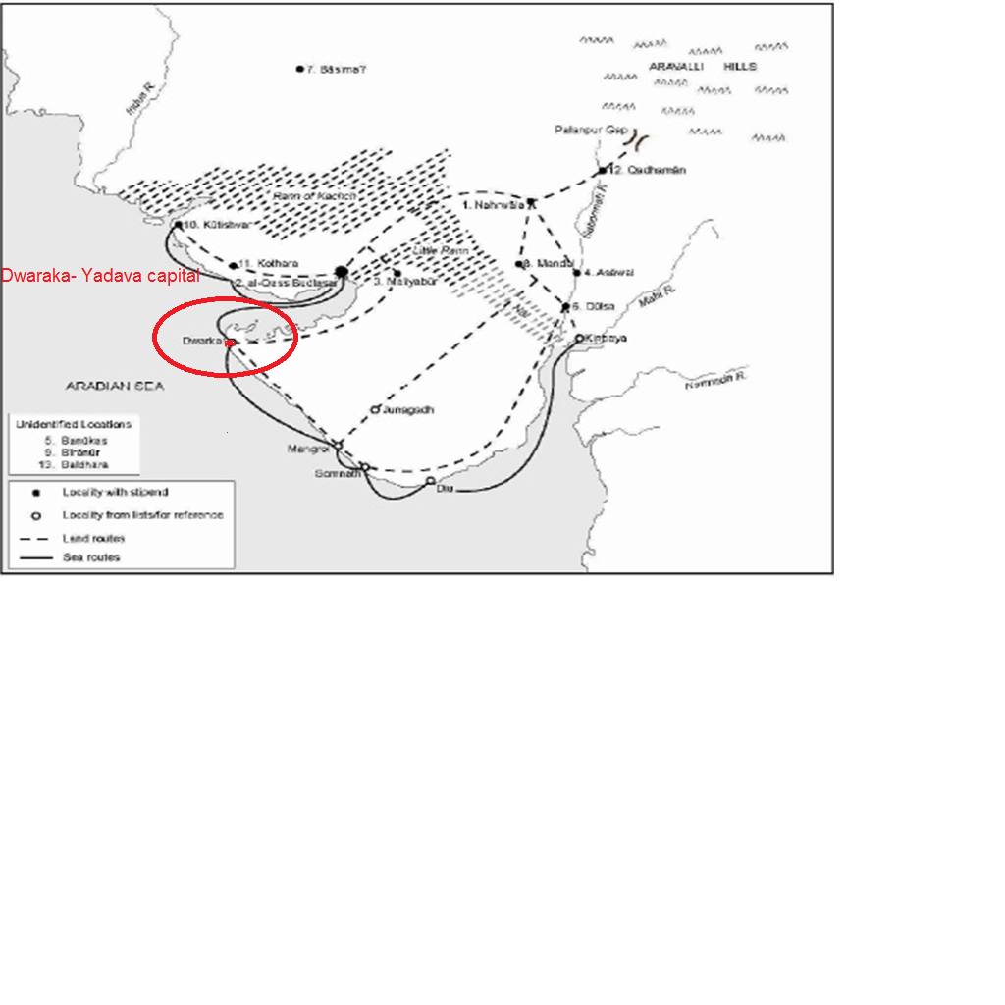 Map 3.4

5.5 Also Jiva Goswami in the XVI century, describes that the remains were visible in that area within the sea. (Vid. Jiva Goswami Tika Krama -sandharva SB 11.31.23) And in his Krishna Sandharbha (181. 16) said:
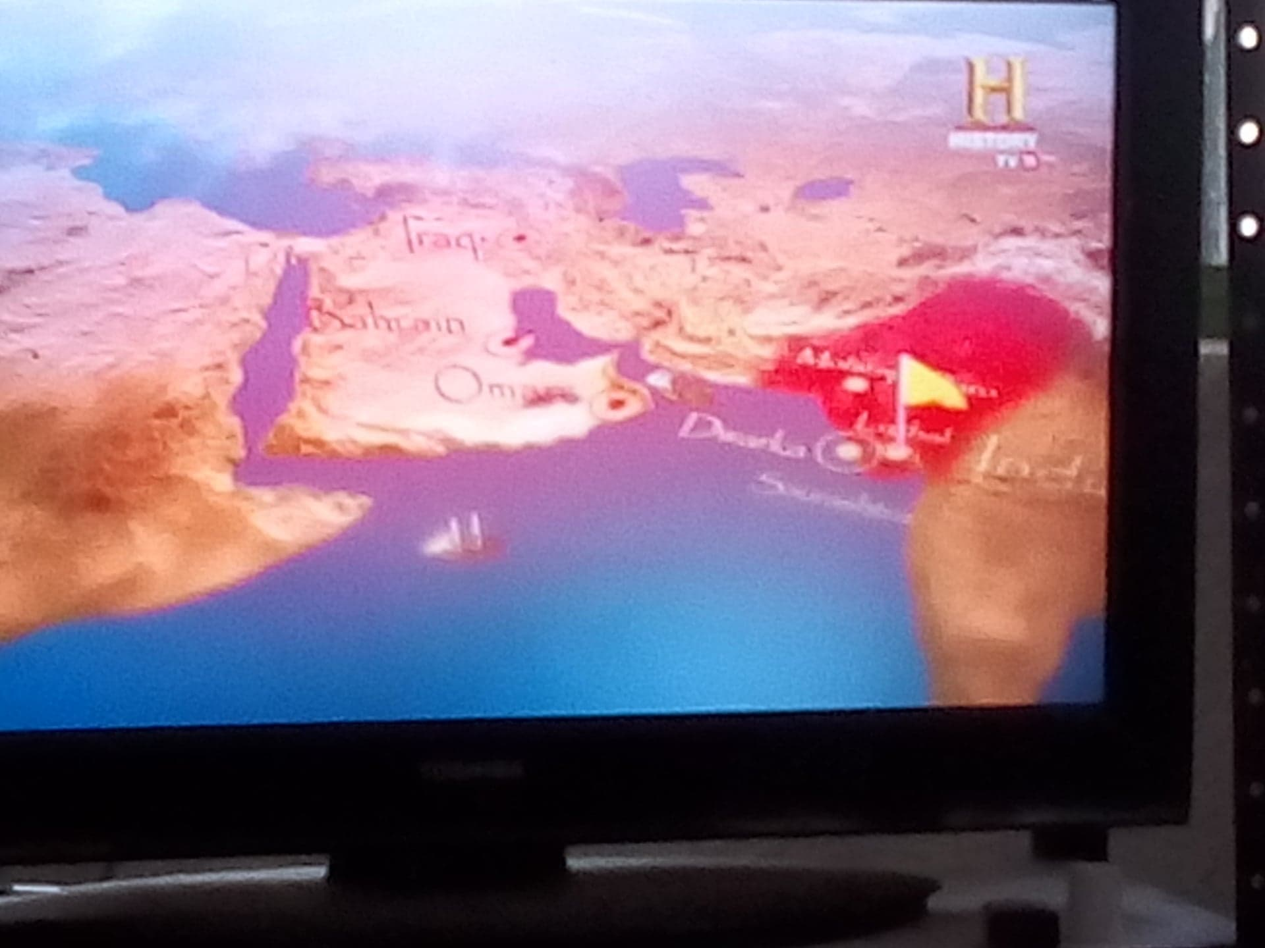

In these verses the word srimat describes Dwaraka as full beauty and opulence because of grand palaces of Yadavas and other residents of the city. After Lord Krishna had abandoned Dwaraka. It was flooded by the ocean, and even today some ruins of what was once Dwaraka may be seen in the middle of the ocean. These remains of Dwaraka are famous among the people who live nearby. (Jiva 1989)
5.6 Epigraphy: The first clear epigraphical record of the lost city is dated 574 A D 1500 years old. and occurs in the Palitana Plates of Samanta Simhaditya. This inscription refers to Dwaraka as the capital of the western coast of Saurashtra and even more important, states that Sri Krishna lived here. But before in the 3th BC 2200 years old Heliodorus‘s Column stated about Krishna: Vâsudeva like the God of gods. In fact there are others B C epigraphical records like Ghosundi inscription, Hathibada inscription, another column of Garuda in Besnagar of a Bhagavata king dedicated to Krishna, The cave of Queen Nagnika in Deccan Inscription or Mora inscription, from Mathura UP, that said: bhagavatâm vrisninam panchavîranam referring to five Vrishni heros. These inscriptions holds the Puranic and Mahâbhârata chronicle on Krishna Yadu’s Clan, without forget that they left Mathura for lived in Dwaraka.
A few years ago, when asked as to how sure he was that this was Krishna's Dwaraka, Rao had replied, "only the name board is missing." Rao also finds confirmation of the reference to Dwaraka as nagara (city) in the Mahâbhârata epic. The high level of civilization in ancient Dwaraka is borne out by the engineering skill, advanced technology and the high literacy of the people. "It was an urban centre with certain specialized industries such as boat building, shell working, pearl diving and perhaps metal working also," ( Rao in STBM 2014). Dr. Rao submitted a proposal to the Ministry of Culture in January 2000, that aimed at preserving the 'underwater cultural heritage of Dwaraka' and also promoting it as a pilgrimage-tourism center. His proposal, in three stages, was to cost Rs 14 crores. It is sad that the proposal was not taken up. The then Secretary, Ministry of Culture, visited Dwaraka and promised help, but nothing has been heard so far.

6, Dwaraka archeological exploration
The objective of the Dwaraka excavation is to know the antiquity of the site, based on material evidence. In the offshore excavation, the ASI's trained underwater archaeologists and the divers of the Navy searched the sunken structural remains. The finds were studied and documented.
On land, the excavation is being done in the forecourt of the Dwarakadhish temple. Students from Gwalior, Lucknow, Pune, Vadodara, Varanasi and Bikaner are helping ASI archaeologists. In the forecourt, old structures including a circular one have been found. A small cache of 30 copper coins was also discovered. Archaeological explorations in and around Dwaraka have been carried out since 1963. The underwater exploration in Dwaraka waters commenced in 1983 to locate submerged city. Offshore explorations during last one and a half decade have yielded a large number of stone structures in a water depth of 3 to 7 m. These structures have been described as walls, bastions and pillars of a habitation area.
The discovery of the legendary city of Dvaraka has also shed welcome light on second urbanization on the resumption of maritime trade. This is a scientific data useful for a study of sea level changes, effects of marine environment on metals and wood, over long periods, has also been generated by underwater exploration. All this was possible because of the dedicated and daring efforts of marine archaeologists, scientists and technicians of the Marine Archaeology Centre of the National Institute of Oceanography.
The Marine Archaeological Unit (MAU) of the Archaeological Survey of India (ASI) conducted a second round of excavations in 1979, under the supervision of Dr Rao Based on the results of these excavations, the search for the sunken city in the Arabian Sea began in 1981. Scientists and archaeologists have continually worked on the site for 20 years. The project for underwater exploration was sanctioned in 1984, directly by the Prime Minister for three years. Excavation under the sea is a hard and strenuous task. The sea offers too much resistance. Excavation is possible only between November and February, during low tide. The sea has to be smooth and there should be bright sunshine. All these requirements effectively reduce the number of diving days to 40 to 45 in one season .In order to make the maximum use of the time available, divers use echo sounder to get a fairly accurate idea of the location and the depth of the object under water. The side scan sonar offers a view of the sea floor. The sonar signals sent inside the water return the signals. Reading of the signals reveals the broad nature of the object under water. Underwater scooters, besides the usual diving equipment like scuba were also pressed into service. Between 1983 and 1990. Rao's team came across discoveries that cemented the existence of a submerged city.
In January 2007, the Underwater Archaeology Wing (UAW) of the Archaeological Survey of India (ASI) began excavations at Dwaraka again. Alok Tripathi, Superintending Archaeologist, UAW, said the ancient underwater structures found in the Arabian Sea were yet to be identified. "We have to find out what they are. They are fragments. I would not like to call them a wall or a temple. They are part of some structure," said A Tripathi, himself a trained diver. (Cit in Rao Op cit)

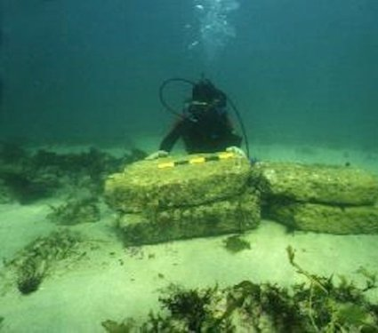
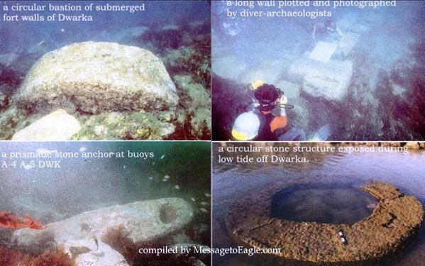

6.1 Findings at the Dwaraka excavation site: Marine archaeological explorations off Dwaraka have brought to light a large number of stone structures. They are semicircular, rectangular and square in shape and are in water depth ranging from inter tidal zone to 6 m. They are randomly scattered over a vast area. Besides these structures, a large number of varieties of stone anchors have been noticed along the structures as well as beyond 6 m water depth. These findings suggest that Dwaraka was one of the most busy port centers during the past on the west coast of India. The comparative study of surrounding sites indicates that the date of the structures of Dwaraka may be from ancient Historical period and even though some anchors, perhaps are from late medieval period; the ruins have been proclaimed the remains of the legendary lost city.
The underwater excavations revealed structures and ridge-like features. Other antiquities were also found. All the objects were photographed and documented with drawings - both underwater. While underwater cameras are used for photography, drawings are done on boards - a transparent polyester film of 75 micron fixed with a graph sheet below. The graph sheet acts as a scale. One or two divers take the dimensions and the third draws the pictures. The Public Works Department routinely conducts dredging in these waters to keep the Gomati channel open. This throws up a lot of sediments, which settle on underwater structures. Brushes are used to clear these sediments to expose the structures.

* Explorations yielded structures such as bastions, walls, pillars and triangular and rectangular stone anchors.

* A semi-spherical single-hole stone which might be the base for flagpost.

* L-shaped edges of stones for proper grip and arresting wave action on bastions.

* Seals, inscriptions, this seal is very similar to Hindu Valley seals???

* Pottery, which have been dated to 3528 BC this means 5500 years old..

* Stone sculptures, terracotta beads, bronze, copper and iron objects.

Two single-holed spheroid stone objects, use unclear, datable to 1500-1400 BC 3400 years ago, were found, besides iron nails, brass objects, a copper bell, a highly corroded copper lota and a few bronze nails. Low zinc brass produced at Lothal in 2300-2000 BC 4400 years old, is similar in composition to that found at Dwaraka.

Marine archaeological explorations have thrown light on a number of structures of different shapes, apart from stone anchors, that fell from ships in medieval ages, the other artifacts according the scientific dating methods are very ancient. The exploration has found sandstone walls, a grid of streets and remains of a sea port, some 70 feet beneath the sea. The evidence points to the fact of the existence of a city some more of 3500 years ago. Also according to them this was one of the most important and busy ports during historical and medieval periods. Similarly, the large number of stone anchors is indicative of overseas trade. The large ships were anchored to the sea, whereas the small ones were near to the warehouses on the Gomati, part of which has been submerged.

The detailed exploration and excavation of this sunken city was started in 1988 with certain goals and results in mind:
1. The explorations were extended up to the Temple of Samudranarayan (Sea God), in order to trace the extent of the port city and the purpose behind the massive stone walls built on the banks of the ancient Gomati River.
2. Whether the architectural features were in conformity to the ones described in the Mahâbhârata.
3. To obtain a more corroborative evidence for reclamation referred to in the epic.
4. The nick point where the Gomati River joined the sea had to be determined.
5. The cause of the submergence

Dwaraka was supposed to have been built on six blocks, two on the right bank and four on the left. All the six sectors have protective walls built of dressed stones of sandstones.
Whatever has been traced so far conforms to the description of Dwaraka in the Mahâbhârata to a large extent. For example, the enclosures may 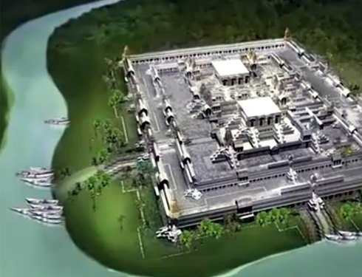correspond to the Antahpuras (harems) of the texts.
The layout of the excavated city, the spread and the location of fort walls and bastions match the descriptions mentioned in Harivamsa, a prologue to Mahâbhârata. Harivamsa described the city of Dwaraka in minute details. According to it, the area of Dwaraka was 12 yojanas. It was connected to the mainland by a strip, which is visible even now, in low tide. The city excavated is of the same size. Harivamsa, detailing the security arrangements, says that there were seals, without which one could not enter the city. Seals of a particular description were found on the seabed. A stone image of Vishnu, blades and pottery are all part of the recovered objects. Certain coins were found during excavations underwater having inscriptions similar to details found in Mahâbhârata.
Elaborating on the town plan of first Dwaraka, Rao's proposal says,

There were two fortification walls. One in the lower terrace and another in the middle terrace. The walls which extended over a length of 4 km on the eastern shore are mostly destroyed by sea action. The walls of the lower terrace are of massive, dressed sandstone blocks while that of the upper terrace are of rubble. The houses and other public buildings, built of smaller size stones within the enclosure are all destroyed and leveled up by the encroachment of the sea. These structures lie in a depth of 7 to 10 meters, below the present mean sea-level, indicating a rise of 10 meters in sea-level during the last 3,600 years." (See Rao 1999, etc.)

6.2 More Identification discoveries of Dwaraka. At Kushasthali (Bet Dwaraka), a strip of sand and stone situated 30 km (19 mi) north of town of Dwaraka, Rao and his team found a wall (560 metres long) visible on the shore itself. Dating of pottery found here gave a date of 1528 BC this means 3500 years based on thermoluminescence dating. Rao asserted the three-holed triangular stone anchors found in large numbers in Dwaraka waters, suggested a continuity in evolution of the anchors in Lothal and Mohenjodaro, which had a single hole, and that the Dwaraka anchors of late Harappan phase are a couple of centuries older than the identical anchors of late Bronze Age used in Cyprus and Syria. However, later on the NIO dated some of these the stone anchors to be of fourteenth century of Common Era. It also stated that similar such anchors have been found in other old ports of India. This issue will discuss later.
Rao asserts that the unearthed remains at Dwaraka were the historical city that was home to Krishna, like was mention early, other discovery in this regards is Vishnu icon found during on shore excavation in Dwaraka. The Mahâbhârata states that people of ancient Dwaraka were Vishnu devotees, that believed that Krishna to was His Avatara. According to the Mahâbhârata, Krishna built Dwaraka at Kushasthali—a fortress in the sea which is currently in ruins. Then he built another city at the mouth of the Gomati River.
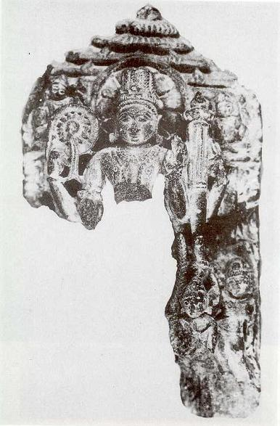

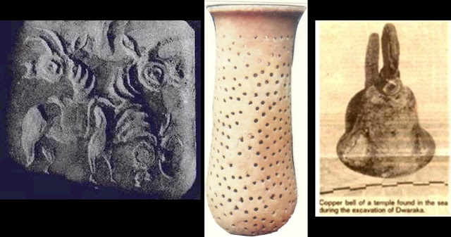
Among the objects recovered from the sea-bed that establish the submerged township's connection with the Dwaraka of the Mahâbhârata was a seal (just 18mm x 20mm) with the images of a bull, unicorn and goat engraved in an anticlockwise direction. "The motif is no doubt of Indus origin but the style shows considerable influence from Bahrain," writes Rao. "The bull, unicorn and goat motif on seals from mature Harappan levels of Kalibangan and Mohenjo Daro is distinct from that of Bet Dwaraka which belongs to the late Indus period." (Rao opus cit) But the seal does corroborate the reference made in the ancient text, the Harivamsa, that every citizen of Dwaraka should carry a mudra as a mark of identification and none without a seal should enter it. The Mahâbhârata. also refers to how Krishna wanted every citizen to carry some sort of identity—a mudra seal:
"When we got the seal we were really excited," said Dr. Rao. "Secondly, we got a stone mound in which they cast some spear heads. So some weapons were definitely locally manufactured. The Mahâbhârata mentions that when Dwaraka was attacked they inserted iron stakes. We got one of those. These are evidences which corroborate what the texts said. But the evidence that really clinched the issue was the mudra and the references to two Dwarakas at the place mentioned in the ancient texts like Sabha Parva." (Rao opus cit)
What Rao and his team discovered was a well-fortified township that extended more than half a mile from the shore. The sketch plan of Dwaraka, prepared on the basis of structural remains exposed in the sea-bed, suggests six different sectors of the town all fortified and some interconnected. Two major roads, each about 18m wide, connect a group of three buildings on the east which formed another designated enclosure, in which six bastions were found in a line. The foundation of boulders on which the city's walls were erected showed that the land had been reclaimed from the sea some 3,600 years back. The submerged township extended in the north up to Bet Dwaraka , also known as Sankhodhara-said to have been the pleasure resort of Krishna and his consorts Satyabhama and Jambavati. The area is noted for its conch shell of good quality which was in great demand as a non-corrosive substitute for metal. It extended up to Okhamadhi in the south, and Pindara in the east. (A pearl fishing village for more than 3,000 years, Pindara is a holy place-Pinda Taraka is mentioned in the Mahâbhârata where sage Durvasa had his hermitage.) The topography of the Okha region reveals seven parts interspersed by the Rann. They may be the seven islands that existed during the Mahâbhârata period and referred to in later texts. The occurrence of proto-historic (1600 BC that is 3600 years old) pottery on land suggests there were smaller towns between Dwaraka and Kushastali in ancient times. With a large port town of Dwaraka, a shipyard in Bet Dwaraka and three other satellite towns at Aramda, Varwala and Nagewsar, the concept of the city state of Darukavana or Dwaravati must have been given a concrete shape,” conjecture Dr. Rao (Opus cit). If all these settlements are taken as one unit, Darukavana extended over 45 km from north to south and at least 25 km from east to west approximating to eight yojanas, if not more. The general layout of the city of Dwaraka described in ancient texts agrees with that of the submerged city and shows evidence of town planning. For example: Land was reclaimed from the sea near the western shores of Saurashtra. A city was planned and built here. Dwaraka was a planned city, on the banks of the river Gomati. This beautiful city was also known as Dwaramati, Dwarawati and Kushastali. It had well-organized six sectors, residential and commercial zones, wide roads, plazas, palaces and many public utilities. A hall called Sudharma Sabha was built to hold public meetings. The city also boasted of a good harbor.
The excavations show that Dwaraka was an urban center with certain specialized industries such as boat building and metal working as evidenced by this copper lota found in the sea bed. Iron too was known to the smiths of Bet Dwaraka. The Sabha Parva text of the Mahâbhârata describes houses, but none had survived the sea. A few paved paths, drains, etc. were traced. Some houses or public buildings had pillared halls. "An idea of the houses built of dressed and undressed stones in ancient Dwaraka can be had from the structures laid bare in the Harappan town of Surkotada in Kutch.
Kushastali is the name given to a pre-Dwaraka (or Harappan) settlement that had been abandoned and reoccupied and rebuilt during the Mahâbhârata period, said Rao, who identifies Bet Dwaraka with Antardvipa of the epic. "The word dvipa as used in the Mahâbhârata often conveys the sense of any land between two rivers or two waters, although it is also used for a continent," said Rao. Also, "the fort wall and submerged walls in the sea confirm the appellation Varidurga, citadel in the water, given to Dwaraka in the Mahâbhârata." (Idem)
The stone mould found in the intertidal zone compares favorably with similar moulds found in Lothal and other Indus towns just as the tidal dock at Lothal built in 2300 BC what it indicates 4300 years, is seen as the precursor of the port installation of Dwaraka. Iron was already known to the smiths of Bet Dwaraka as attested to by iron stakes, nails and other iron objects. Terracotta wheels of toy carts were also recovered. By 1500 BC around 3500 years ago almost the entire township seems to have been destroyed. But while it existed, one later description of the city reads, "The yellow glitter of the golden fort of the city in the sea throwing yellow light all round looked as if the flames of vadavagni (volcano) came out tearing asunder the sea."
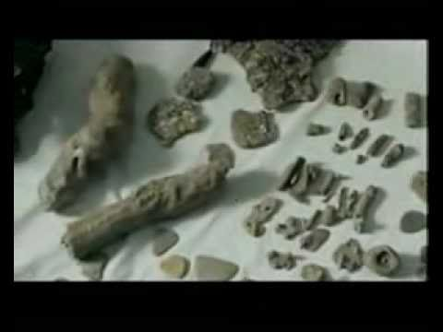

Also, the Dwaraka harbor provided the earliest clear evidence of modifying natural rock to serve the needs of a harbor. Two rock-cut slipways of varying width extending from the beach to the intertidal zone were discovered, which could have been designed for launching boats of different sizes. This technique was adopted by the Phoenicians much later, around 900-800 BC approximately 1900 years ago. The structures and the large stone anchors lying under the sea at Dwaraka are also seen as indicative of large ships being anchored out at sea while smaller boats carried men and cargo up the river. Among artifacts recovered from Dwaraka and Bet Dwaraka were pottery carrying inscriptions in old Indo-Aryan (Vedic or archaic Sanskrit) script and were found to be 3,528 years old in thermoluminescence testing. Rao associate one of the potsherds recovered to read baga (God) in late Harappan characters and assignable to 1800-1600 BC that is around to 3500 old and another as Mahakaccha sah pa, conveying the sense of "sea (or sea god) king (or ruler) protect"-an appeal to the sea god for protection. A similar appeal has been in a seal inscription from Mohenjo Daro.

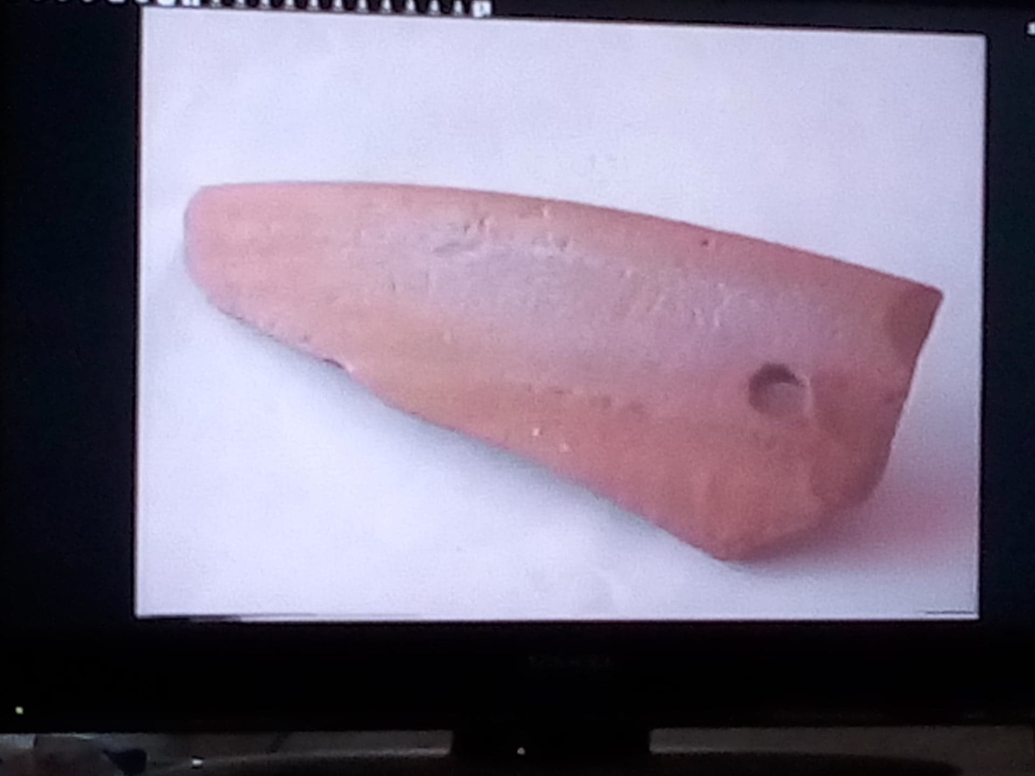

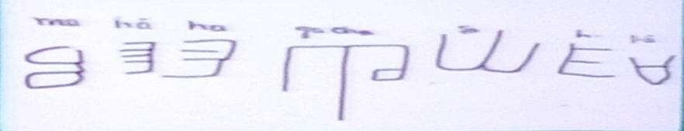
Triangular three-holed anchors weighing 120-150 kg, the biggest weighing 560 kg, found were similar to pre-Phoenician anchors found in Syria and Cyprus and were dated around 3500 years ago or 1500 BC. Another archaeologically significant find was a lunate shaped moonstone (chandrasila). This and a beam found in the vicinity suggested to Rao's team that there existed a temple here. Stone artifacts recovered from the sea-bed included a low footed stool of basalt, finely polished found along with brass arches, a pestle of granite and a grinder cum pounder of dolerite. Two single-holed spheroid stone objects, use unclear, datable to 1500-1400 BC were found, besides iron nails, brass objects, a copper bell, a highly corroded copper lota and a few bronze nails. Low zinc brass produced at Lothal in 2300-2000 BC that is 4300 years ago, is similar in composition to that found at Dwaraka. (See in appendixes end more ruins photos)
7. What really happened to Dwaraka?
The rise in the sea-level in Dwaraka is a scientific truth. Studies have proved that the sea considerably and suddenly rose to submerge the city. Harivamsa describes the submergence of Dwaraka saying Krishna instructed Arjuna, who was then visiting Dwaraka, to evacuate the residents of the city as the sea was going to engulf the city. "On the seventh day (of Krishna saying this), as the last of the citizens were leaving the city, the sea entered the streets of Dwaraka." According to experts, there could have been three reasons why the sea entered the land. One, a change in the level of seabed, two, a massive earthquake and three, sudden increase in the level of sea water. Of the three, the last is the most plausible. If it was a change in the level of seabed, some remains of the "tearing off action" on the shore would be visible, which is absent. Earthquake can be ruled out as the structures have not collapsed because of the quake. The third reason is most acceptable as a similar phenomenon had occurred in the shores of Bahrain, around the same time, as some recent findings indicate. It is to be noted here that considerable work has been done on shore and offshore underwater excavations in Bahrain, which has indicated a deep and regular trade and other relations between the western coast and the coasts of the present-day Bahrain region.
In the project proposal, Rao writes, "The fort walls of the first town of Dwaraka said to have been founded at Kusasthali in Bet Dwarka island have been traced on shore and in the sea and also dated by thermoluminescence dating method to 16th century BC." (Opus cit) According to him, the clue to the existence of ancient Dwaraka near the modern town of Dwaraka was found during archaeological excavation near the Dwarkadhish temple in 1979-80. Eroded debris and pottery provided evidence of a port town destroyed by sea about 3,500 years ago. This evidence is what led to the early excavations in the Arabian Sea, near the mouth of the Gomati river, where the modern town of Dwaraka stands.
The proposal envisaged a three-stage heritage conservation. This was to be done along with further excavations in Bet Dwaraka. It was suggested that access to the submerged city in Dwaraka water can be given to visitors, in fair season, through underwater acrylic tubes or viewing chambers at specific points. Such facilities exist in Singapore and Auckland (New Zealand). Alternatively, underwater video cameras can be used to project images above water, in monitors.
The project also mooted the idea of a submarine museum of dolphins as they are in good population in deeper water, off Dwaraka. There is also a strong case for a Maritime Museum of Antiquities found in excavations at Dwaraka, Bet Dwaraka, Somnath, Nageswar and dioramas of Lothal port and Modern Dwaraka city. As of now, the Dwaraka antiquities are lying in NIO, Goa.
It is again a telling story of the system in India, which is the cause of lack of interest in the project. Such a discovery in any other country would have been approved and encouraged. The excavation on Dwaraka was done by Rao, who was with the National Institute of Oceanography, Goa. Though work remained to be done, the CSIR, under whom falls the NIO, did not release the funds. Further extension to Rao was not given as he had already reached the age of 72 and He pass away in the age of 91 in 2013.

8. Discussion of Date problems
The mainstream chronological model based in Max Müeller ideas says that Rig-Veda is the oldest text, introduced in India around 3500 years ago in 1500 B.C. by the Aryan invader tribes coming from the Caucasus (early scholars said that they came from Europe or Iran) and the other texts had been gradually compiled in the course of centuries. This theory gives some historical recognition to the Mahâbhârata War and its protagonists such as Krishna, but as the later epic rendition of a primitive society around 2900 year ago the 10th century B.C. According to this theory, sage Vyasa and his successors the Vyasas, compiled the Mahâbhârata and related texts starting from the 5th century B C., until the later compilation of the Purânas between 1500 till 800 year ago the 5th and the 13th centuries D C.

8.1 This model has been a useful tool for scholars; but unbiased investigators have recognized that it presents several difficulties that cannot be solved, and above all it is nothing more than a non-verifiable hypothesis. It is sad to say; but even today, there are advocates to (AIT) and the Müllerian dating model of Vedic texts, which alienate and disassociate themselves from reality, before the archaeological evidence and discoveries that demonstrate the unreal of that model ... Currently, some researchers change the word with ―migration and others suggest both ―migration-invasion, others ―from outside and inside or both? However, there are scholars, more Archeologists, like Jim Shafer that demonstrates how:

The Indo-Aryan concept never was subject to rigorous validation beyond the field of historical linguistic. Linguistic reconstruction were used to interpret archeological materials, which in turned were used to substantiate the original reconstructions.
The Indo-Aryan invasion as an academic concept in 18th -19th century in Europe reflected the cultural milieu of that period… What was theory became unquestioned fact that was used to interpreted and organize all subsequent data.
Archeological data not support the existence of an Indo-Aryan or European invasion into south Asia any time in the pre- or proto-historic periods. Instead, it is possible to document archeologically a series de changes reflecting indigenous cultural developments from prehistoric to historic periods. (Shafer 1984:88).

There are others examples that demonstrated the same, like Jonathan Mark Kenoyer:

There is in fact no archeological or literary evidence of invasion during this period of Indus civilization‘s decline. Concurrent theories take into account main factors that would have contributed to fragmentation of society, including the breakdown of agricultural life, the migration of people following changes in rivers courses, and the failure to maintain political and economic control over the vast region. (Kenoyer: 55)

Although undoubtedly the origin of such one Indo-European community in itself, is something that in the present is outside the scope of scientific knowledge, the truth remains ignored.

8.2 About the dating Müeller model of Sruti Smriti vedic –puranic literature, since 1500 BC to later, is very easy quote scholars that disclosed how is groundless. Max Muller was one of the first to reject his own paradigm: "Whether the Vedic hymns were composed in the 1000 or 1500 or 2000 or 3000 B. C., there is no power on earth that will determine it. (Müeller, 1899: 35) Similar statements by himself appear in two other of his texts.. (Müeller, 1883: 21; Müeller, 1869: 163). " In this respect S. Piggot revealed:

Max Müller insisted that these dates were only minimal dates, and later there was a kind of tacit agreement (no doubt by the influence of the Mitanni Aryan documents discovery around 1380 B.C. with the names of the gods mentioned in the Rig Veda) to date the composition of the Rigveda between 1500 and 1400 BC. C. But without conclusive evidence. (Piggot. 1966: 214)

The American Sankristist W. D. Whitney wrote: ―All dates in India literary history are pint set up to be bowled again… For most part is still the case (Cit in Winterniz 1972; 27). Therefore, Moris Winterniz pointed out:

It is remarkable, however, how strong the power of suggestion is even in science. Max Müeller‘s hypothetical and purely arbitrary determination of the Vedic epochs, in the course of the years, received more and more dignity in the character of a scientifically proven fact, without any new argument or actual proof been added (Idem).

8.3 The official date of 2900 years ago 10th BC for Krishna’s and Mahâbhârata epoch is based in the dating of Buddha Siddharta in 500 BC that is 2500 years ago. Other arguments in establishing the antiquity of Krishna’s times is exemplified by the calculation offered by the critics Colebrook and Wilson. According to them, the Bhâgavatam must have been compiled in the 13th century CE, because the 12th Canto gives a chronology from which it is evinced that king Pariksit, described in the beginning and in the end of the text, lived 1300 years before king Chandragupta Maurya. The chronology seems to mention also three Andhra kings, tentatively dated around 1900 years old in the 2nd century CE.
The entire association is based on a reference from the Greek historian Meghasthenes in 300 BC in his work Indika, where he mentions king Sandrakutus, identified by later scholars as king Chandragupta Maurya. These conservative scholars believed this to be the equivalent of the Rosetta Inscriptions stone, and on this calculation all the chronology of Indian history was built. The theory elaborated on Chandragupta Maurya‘s grandson, King Asoka Maurya, who was identified like a Asoka converted to Buddhism, that financing its expansion and organizing its councils, and who was deemed to have lived in 2200 years ago the 2nd century BC. Thus the Battle of Mahâbhâtara was deemed to have been fought in around to 3000 years ago the 10th century BC.
But there are difficulties in this tine scenery because, according to Jiva Gosvami Buddha appeared when two thousand years of the Kali age have passed: tatah iti ayam kaler abda-sahasra-dvitiye gate vyaktah. (Krishna-sandarbha Vol. I anuccheda 24) That means around 3102 year ago the 1102 BC. And in the first reconstruction of Hindu chronology by Sir William Jones, Lord Buddha is appointed to the same 1027 BC. (Thompson 1994), There are astrological references in the Buddhist sources that Sidhartha born almost 3800 years ago in 1800 BC. (Ghokale 1996)
The other weak point of this claim is that Meghastenes made no mention of Chanakya, the great minister of king Chandragupta Maurya, and neither did Chanakya ever mentioned in his works any Greek like Alexander or Meghastenes who visited the court of Sandrakutus. Another problem is that the two kings mentioned by the Greek historian as preceding and succeeding Sandrakutus were Xandramas and Sandrocyptus. Such names have no resemblance whatsoever with the names of Nanda or Bindusar and Asoka, the kings whose lived before and after of Chandragupta Maurya.
The only phonetically acceptable resemblances are among linage Rulers of king Chandragupta-Gupta I: Chamdramas=Xandramas, and Samudragupta=Sandrocyptus. This means that the dating system must be rethought. This evidence, presented by Dr. Prasada Gokhale from University of New Brunswick in Canada, suggest that Chanakya lived around 3500 years ago in 1534 BC and king Chandragupta I 2325 years ago in 325 BC, when he entered diplomatic relationships with Alexander the Great. Still another problem is that the Buddhist Asoka was a king of Kashmir and not the grandson of emperor Maurya's Asoka. (Cfr. Gokhale 1996) This is significant, because it justifies this investigation, since it coincides with the historical version in Srîmad-Bhâgavatam. Other example of erroneous calculations is the follow argument:

According to the inscription Aihole of Pulakesin II, 700 AD, the Battle of Bharata occurred in 3102 BC, in which the Kali-yuga era began according to the astronomical tradition represented by Aryabhata. Another school of Hindu astronomers and historians represented by Vridda-Gaga, Varahamihira and Kalahana, puts the battle in 2449 BC. . . We can, therefore, take the 1400 B.C as provisional date for the battle (of Kuruksetra); and the event must have taken place between that date and 1000 BC. (Cit in Gambirananda 1984)

Where is the objectivity? In other words, the conclusive scores are leaving the real evidence to speculative jumps of imagination like blind shots in the air, so imagine that this extrapolate way was used to calculate anti-aircraft ballistics?

Nb. The author of this paper was asked to Dr. Dominid Wujastyk, director of the international forum Indological List on the Internet, about the date of Buddha, which was confronted with all those findings already show here and his response was very objective: “So far, I'm afraid I could not respond.”

8.4 However, in the recent years several questions have been raised about the dating and the original purpose of the structures off Dwaraka. The underwater explorations of 1997-98 and 1998-99 were carried out to re-examine and compare the findings with surrounding sites. It appears that submerged structures of Dwaraka may be part of an ancient jetty. A detail discussion has been conducted on underwater structures, stone anchors and other finds, based on the recent exploration in the adjoining areas of Dwaraka. Admittedly, there is not such dispute about the general area of Krishna's kingdom. “The dating of Rao's material was done, not by archaeologists, but by scientists at the Physical Research Lab, and that cannot be disbelieved. So it is definitely ancient Dwaraka," said Dr. M. Acharya (Rao Opus cit). But in terms of time, Rao's explorations place Krishna and the Mahâbhârata in the post-Harappan period or after the break-up of the Harappan empire due to natural causes around 2200-1900 BC that is 4000 years old. "Generally our findings have been accepted," said Rao (Ibidem).

8.4.1 Thesis: "There are a few who think that the date 1700-1800 BC (3600 year old) that we have assigned is not in consonance with the traditional date of 3102 BC (5000 years ago). But so far as the archaeological evidence from on shore and off-shore excavations and thermoluminescence dating is concerned Kushastali with its late Harappan relics where the first Dwaraka was built may be assigned to 1700 BC and the town on the mainland may be slightly later," Rao said. "Although traditional date of 3102 BC cannot be confirmed by available evidence, it is better to explore deeper waters of Bet Dwaraka," (Rao 1999) This last opinion shall discuses more later.
"There is one other possibility. In Bet Dwaraka there are the mudflats. We are not able to dig because you hit water at an early depth and neither diving nor excavations are possible." (Idem) Archaeological excavations show that modern Dwaraka is the seventh settlement of the name on this site. It is now generally accepted that the earlier cities have been, at various times, swallowed by the sea. Interestingly, the only ancient temple for Matsya, Vishnu's incarnation at the time of the great flood, is to be found at Sankhodhara in Bet Dwaraka. The structures and stone anchors lying under the sea indicate large ships being anchored out at sea while smaller boats carried men and cargo up the river as visualized in this artist's impression of the harbor of ancient Dwaraka. Madhav Acharya too favors the later dates.
"There is a difference in the geographic areas as well as the time frame of the Saraswati civilization that is wholly Vedic, and the setting of the Mahâbhârata ," he said. According to him, while the Saraswati-or the Harappan-civilisation centres on the Saptasindhu rivers (the Indus, the Saraswati and the five rivers that make up Punjab), the Mahâbhârata has the Ganga and the Yamuna, besides the Kurukshetra area in Haryana, as the backdrop. "The earliest habitation in the Ganga-Yamuna region does not go back beyond 1200-1100 BC, and in Mathura and the Mahâbhârata sites there is no evidence of earlier inhabitation." (Acharya in STBM 2014)
8.4.2 Anti-thesis: The date arguments notwithstanding, there can be no denying the importance of Rao's findings. Others researchers, view Rao's discoveries as confirmation of their theories that the Mahâbhârata belongs to a much earlier period. Low zinc brass produced at Lothal in 2300-2000 BC that is 4300 years ago, is similar in composition to that found in artifacts like this bronze bell excavated at Dwaraka. Also, a stone mould compares favorably with similar mould found in Lothal and other towns from Shindu Culture of 5000 years old. The second reason cited is that Krishna of the Mahâbhârata and the archaeology of his Dwaraka must fit the picture of the region and society portrayed in the ancient texts, better fits in the early Harappan (3000 BC that 5000 years ago) period than the post Harappan period favored by Rao and some others. Especially since some of the artifacts recovered from the sea-bed show a strong affinity with West Asia, especially the Kassite empire of Babylon. The third reason is the mismatch between the political situation described in the Mahâbhârata and the picture given by post-Harappan archaeology. There can be little doubt that Krishna was a figure in late Vedic period, (See Rao in STBM 2014) According to The Mahâbhârata, Krishna's links were with the Kurus, the Panchalas and Mathura, all in the Vedic heartland to the north. "Just as there is no denying the Kassite influences on Rao's Dwaraka, there is no denying the historic Vedic link between the Purus (or Kurus) and the Yadus along the Sarasvati river, which should place them before the complete drying up the ancient river around (4000 years ago in) 2200-1900 BC." (Idem)
The seal found, establishes the submerged township's connection with Dwaraka of Mahâbhârata. It corroborates the reference in the Harivamsa that says every citizen of Dwaraka should carry a mudra as a mark of identification. Further, the Mahâbhârata describes India as made up of established kingdoms, with good communications and a common elite language. "It was an age of large kingdoms and empires and imperial aspirations," (Idem) In fact the geography as described in the epic is accepted by many scholars. Historian S.M. Ali is quoted in Rao's book:
"The georgrapahical matter contained in the Mahâbhârata is immense. It is perhaps the only great work which deals with geographic details and not incidentally as other works." ( Rao Opus cit)
So Krishna's Dwaraka must fit into the geography and society described in the epic, which obviously corresponds far more to the early Harappan rather than the post-Harappan period which saw the rise of regional cultures, what Rao calls Janapadas, (Rao gives the following chronology: Pre-Harappa 3400-3100 BC; mature Harappa 3100-1900 BC; late Harappa 1900-1500 BC. That means 5400 years ago)
9. Synthesis
However, It is necessary must be aware that the dating methods such as carbon 14, thermoluminescence and others, are shown to yield solid data on possible dating, but they are subject to ranges and average error, so these are approximate and not infallibles ones, as some experts have shown this point and published in scientific treatises such as in Science magazine, No. 130, dated 11 December 1959, Nature No. 225 7 March, 1970, etc. (See Cremo &Thompson 1998) In addition, all archaeological sites are never monolithic, but there is a stratigraphy of layers, of different levels and epochs. What to say in a port, which was a maritime route of very heterogeneous activity? Therefore, the more oldest relics must be taken into consideration to know how ancient these sites are. For example, if some mobile phones are found in archeological excavation, that would only be an evidence of contemporary pollutions. So, anchors have been found that are similar to others discovered in other ports of more recent times. Among the 75 stone anchors found in the area, 12 ring stone anchors are with a circular flat bottom, tapering towards the top, and with a circular excel hole in the center. The other types include those with a flat top and bottom, a rough and porous surface. These are mostly made of limestone and very similar to those found in Oman, East African coastal countries, Sri Lanka, Maldives and Tamil Nadu in context of early to late medieval period. Evidently, Dwaraka was a very active port town during medieval period. The dates of these anchors are assigned between 10th century to 14th century AD or approximately 800 years ago. Although in Dwaraka others triangular three-holed anchors weighing 120-150 kg, the biggest weighing 560 kg, are found were similar to pre-Phoenician anchors found in Syria and Cyprus and were dated around 1500 BC, are also similar to those of the Phoenicians in ancient times, 3,500 years ago too. The stone mould found in the intertidal zone compares favorably with similar, moulds found in Lothal and other Indus towns just as the tidal dock at Lothal built in 4300 years old 2300 BC.
Like Dwaraka, Somnath (Prabhasa) is a holy place with historical importance. It is mentioned in the Mahâbhârata as Prabhasatirtha. Bhâgavatam Purana says that at this sacred place the river Saraswati flows towards the west and the town is situated on the seashore. The Nasik and Karle caves inscriptions of Nahapana (119-124 AD almost 1900 year) also refer to Prabhasa. Offshore explorations were carried out in the southwest direction of Somnath Temple covering an area of 500 square meters. The seabed at this location consists of disturbed rocky bed and at a few places it is plain rock bed. A few channels are also present. Many archaeological objects have been recorded including a large number of ring stones from Somnath waters. A few ring stones, made out of basalt rock and others of limestone datable to medieval period, have been found and their function, however, remains an enigma. Six stone anchors, two of grapnel type and four of triangular type noticed in Somnath waters, are very similar to those found at Dwaraka.

The seals of Mohenjo Dharo and Harappa are similar to mudra found in Dwaraka, which coincide with those mentioned in the Harivamsa. The pottery that contains characters are similar to those of the Cultures of the Hindu. In short, even an archaeologists with a strong Jacobin tendency have recognized that the oldest finds in Bet Dwaraka date back to 5000 years ago 3000 BC. (See Vora et alt 2019 ) And this site was also associated with Krishna’s Dwaraka. And another relevant discovery that Krishna and Dwaraka´s times coming from this 5000 years old 3000 BC is a tablet found in the Mohenjodaro sites, which depicts Krishna like baby Damodara releasing the Kuvera ‘s sons and is dated to 4600 old 2600 B.C (Mackay's report, Part 1). By Ernest John Henry Mackay (5 July 1880 – 2 October 1943), he was an archeologist from Bristol and is well known for his excavations and studies of Mohenjo-daro and other sites belonging to the Indus Valley Civilization.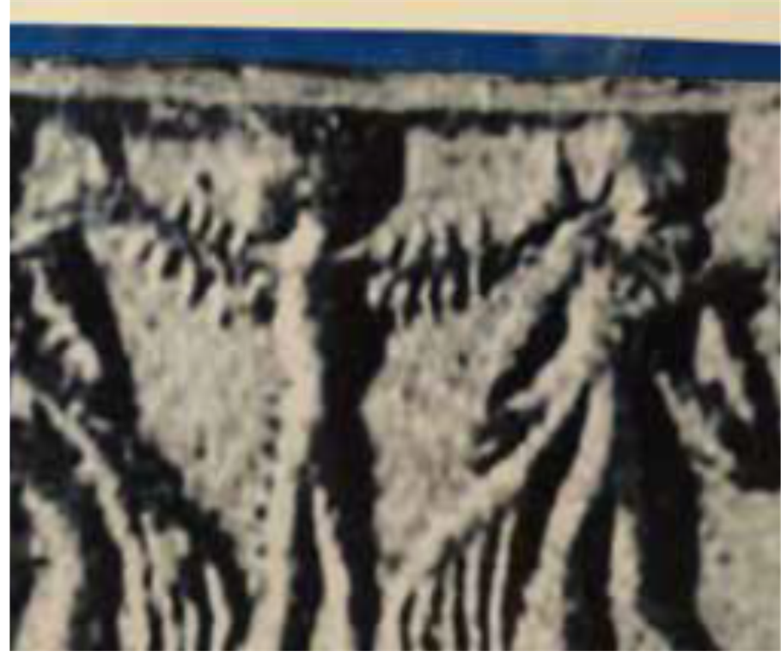
Steatite from Mohenjodaro, dated to around 2600 BCE Source : Mackay’s report, Part I, pp-344-45, Part 2, plate no. 90, object no. D.K. 10237

9.1 Gulf of Khambat Exploration and Findings
In 2001, the students (among them the distinguished now Dr. Badrinarayana) of National Institute of Ocean Technology were commissioned by the Indian Government to do a survey on pollution in Gulf of Khambat, seven miles from the shore. During the survey, they found buildings made of stones covered in mud and sand covering five square miles. Divers have collected blocks, samples, artifacts, and coppers coins, which scientists believe is the evidence from an age that is about 3,600 years old. Some of the samples were sent to Manipur and Oxford University for carbon dating, and the results created more suspicion since some of the objects were found to be 9000 years old. It is indeed overwhelming to find that what had been discovered underwater at the Gulf of Khambat is an archaeological site, dating back to 9000 years old 7500 BC and older than any previously claimed oldest sites of civilization.
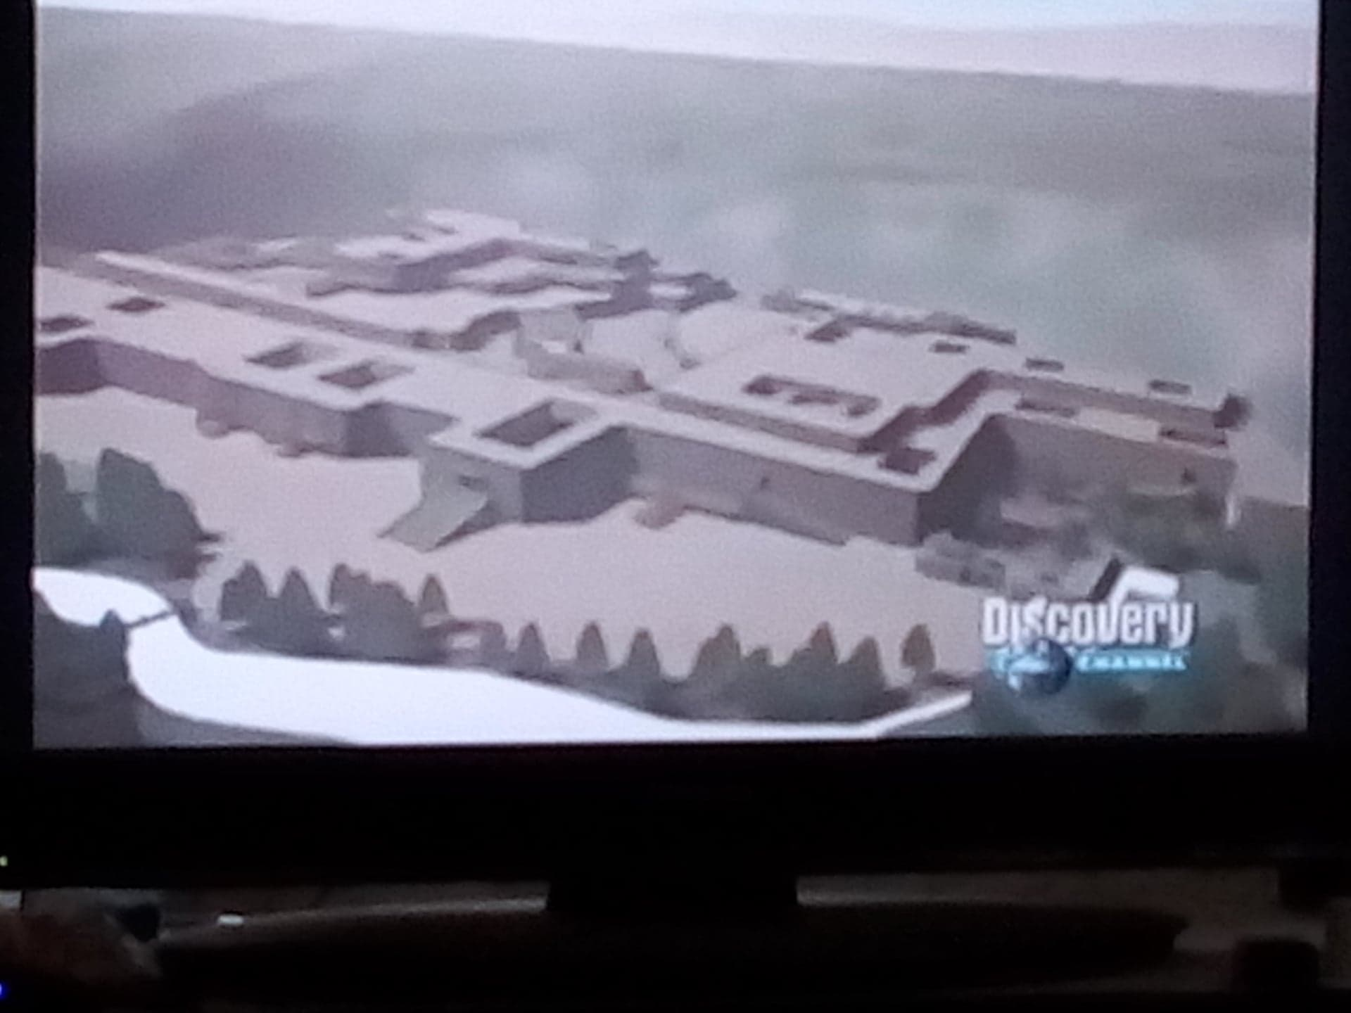

On the other hand explorations conducted in the Gulf of Khaambat waters revealed sandstone walls, a grid of streets and some evidence of a sea port 70 feet under water, and artifacts dating back to 7500 BC. Among the artifacts recovered were a piece of wood, pottery sherds, weathered stones initially described as hand tools, fossilized bones, and a tooth. Artifacts were sent to the National Geophysical Research Institute (NGRI) in Hyderabad, India, the Birbal Sahni Institute of Paleobotany (BSIP) in Lucknow, India, and the Physical Research Laboratory in Ahmedabad, India. The piece of wood was carbon dated to an age of 9,500 years old. Also, were dated by the National Institute of Ocean Technology established with carbon-14 circa 7,500 to 9,000 years, the wood samples excavated from under the sea and the existence of a civilization dating to that period. Perhaps it might not be directly connected with Krishna's Dwaraka, This, however, might help in ascertaining the rise in the sea-level about 30 meters in 7,500 years, approximately at the rate of 10 meters in 3,500-3,800 years. Therefore which Dr. Rao concluded , existed some 4,000 years ago.
NIOT returned for further investigation in the Gulf from October 2002 to January 2003. During these excavations, NIOT reported finding two paleochannels flanked by rectangular and square basement-like features. Artifacts were recovered by means of dredging, including pottery sherds, microliths, wattle and daub remains, and hearth materials. These artifacts were sent for dating at the laboratories of Manipur University and Oxford University and were concluded to be 9000 years old. Mainstream scientists maintain that ancient Indian culture/civilization goes back some 4-5 thousand years. Yet the ruins below the Gulf of Kambhat go back at least 9 thousand years proving that the ancient Indian civilization is much older than originally believed. (See New Indian Press 2018)

9.2 Calculations by computer simulation Modelling sea level.
As it was said before, there is evidence that tends to support carbon dating 14 of 7,500 years of the Gulf of Kambhat It is found by simulation of sea flood in India, by Dr. Glenn Milne of Durham University, that the land mass off the coast of Khambat, Gujarat, India, might be between 7000 and 12,000 years old. That means what the Khambat Gulf ruins could coming from those times, because the current Dwaraka Bahia as we know it now , etc., were over land in those times, and ancient Dwaraka was built there, connected with Bet Dwaraka, Lothal, etc. But according to Puranic and Mahâbhârata chronicles, Krishna reclaimed this land from ocean, which means that the bay was already inside the ocean and after His departed, was food by the sea again. That means Dwaraka ruins were a time after that of Khambat.

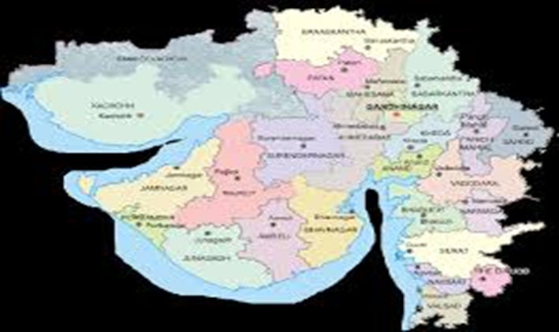
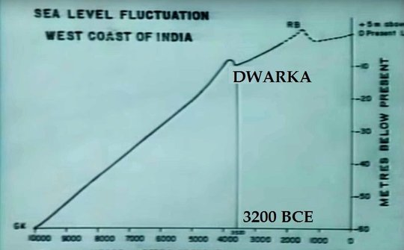

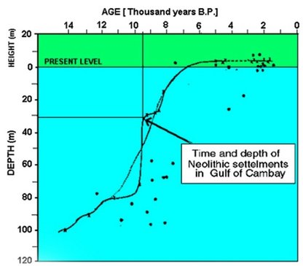

9.3 Mahâbhârata archeology
In 2003, the C P Art Centre in Chennai, T K V Rajan, archaeologist turned television producer, presented an exhibition titled "In Search of Krishna", a well-documented collection of material about the excavations conducted at the various sites connected with the life of Krishna and the events of the Mahâbhârata. In view of the ongoing excavations at Ayodhya, it is worthwhile to see what the Mahâbhârata excavations revealed.
Over 35 sites of the Mahâbhârata have been identified in the North, all of which have yielded material culture - painted grey ware (PGW) pottery painted over with designs in black pigment, and antiquities in uniform and identical levels. This pottery is made of a superior quality of paste formed of well levigated clay and fine, well-burnt fabric achieved by distributing heat in the kiln evenly. This civilization is also characterized by the use of iron, unknown to the earlier Harappans.
Hastinapur, between Meerut and Mawana in Uttar Pradesh, is now a forgotten village, but excavations in 1952 revealed the existence of Vidur-ka-tilla (Vidura's palace), Draupadi-ki-rasoi (Draupadi's kitchen) and Draupadi Ghat (for bathing), besides copper utensils, iron seals, ornaments made of gold and silver, terracotta discs and several oblong-shaped ivory dice used in the game of chauper. Iron objects numbering 135, and which included arrow and spearheads, shafts, tongs, hooks, axes and knives indicate the existence of a vigorous industry. There are indications of brick-lined roads and drainage systems, and an agro-livestock based economy. The PGW of Hastinapura have been assigned a date fitted to the dominant conservative paradigm of official history 1100-800 BC circa 3000 years ago. Later, according to the Matsya and Vayu Puranas, a heavy flood on the River Ganga destroyed Hastinapura, and Nichakshu, the fifth king after Parikshit (Arjuna's grandson) who ascended the throne after the Kurukshetra war, shifted his capital to Kausambi, 50 kilometres from Allahabad. There is definite archaeological evidence of a massive flood level. The devastation by the Ganga is still visible in the thick clay soil.
After their exile, the Pandavas asked for three villages: Paniprastha, Sonaprastha and Indiraprastha, generally identified with modern Panipat, Sonepat and Puranaqila in New Delhi. These sites have also yielded the same pottery and antiquities. Building structures with drainage systems and PGW were excavated at Purana Qila.
Kurukshetra, now in Haryana, was the site of the Kuru war. Excavations here have yielded iron arrow and spearheads, dated by Thermoluminence (TM) to 2800 BC goes back to some 5 thousand years. Today it is a town of bathing pools. At the Brahma Sarovar, a large lake 3,600 feet by 1,500 feet, Krishna, Balarama and Subhadra are said to have bathed after a solar eclipse and Bhishma lay on his bed of arrows in Bhishma Kund. The most remarkable aspect of both epics is their geography. The Mahâbhârata mentions many small villages, tanks and hills, which are still identifiable. (Krishna, N. 2003). Archaeological excavations at Hastinapura, Kausambi, Indraprastha (Purana Khila), Panchala and many other places connected with the Mahâbhârata as well as Thermoluminiscence techniques at nearby Lal Quila have thrown up finds that peg existence of civilization there all through the period from around 800 BCE back to 2800 BCE, which is again close to 5000 YEARS Kali Yuga in star in 3102 BCE . (Hari et alt 2017)

9.4 Sarasvati river investigations.
There is a book available that goes further into the details of the Saravati river
research, 'New Discoveries About Vedic Sarasvati' by Dr Ravi Prakash Arya. He is the Chief Editor of Vedic Science journal. According to the Remote Sensing Agency, Hyderabad, India, the Sarasvati River flowed from the Himalayan Glaciers through Gujarat and joined the Arabian Sea in Gujarat .The river was 22 km wide! It flowed in Parallel to River Indus (Sindhu) This was found from the Satellite Images. And based on the melting of Himalayan Glaciers, Sarasvati River had flown between 10000 and 4000 years ago. (Khonde 2019). Satellite images, supported by a four-year drilling exercise, which was guided by ancient literature, have established that the river Sarasvati left its channel inscribed in the geological layers. It was a huge river that died a premature death about 5,000 years ago, and is now buried 60 meters below the ground. A map of all the channels discovered so far leads one to conclude that it was probably 1,500 km long, three to fifteen kms wide, and about five meters deep. The river probably crisscrossed the present-day states of Himachal Pradesh, Haryana, Punjab and Rajasthan. The specialist S C Sharma, says it continues to flow to the sea underground at a rate of 20 metres a year.
Scientists say new evidence could unearth the Saraswati. The narrative of the mighty Sarasvati river has lived on in India since time immemorial, and now is confirmed. Ancient Sanskrit sources, Vedas, Mahâbhârata and Puranas, have hymns about it being the life-stream of the people. This River was associate with the Dwaraka’s residents times:
SB 3.1.17 — By his piety, Vidura achieved the advantages of the pious Kauravas. After leaving Hastināpura, he took shelter of many places of pilgrimages, which are the Lord’s lotus feet. With a desire to gain a high order of pious life, he traveled to holy places where thousands of transcendental forms of the Lord are situated. B 3.1.18 — He began to travel alone, thinking only of Kṛṣṇa, through various holy places like Ayodhyā, Dvārakā and Mathurā. He traveled where the grove, hill, orchard, river and lake are all pure and sinless and where the forms of the Unlimited decorate the temples. Thus he performed the pilgrim’s progress. SB 3.1.21 — At the place of pilgrimage at Prabhāsa, it came to his knowledge that all his relatives had died due to violent passion, just as an entire forest burns due to fire produced by the friction of bamboos. After this he proceeded west, where the river Sarasvatī flows. SB 3.1.22 — On the bank of the river Sarasvatī there were eleven places of pilgrimage, namely (1) Trita, (2) Uśanā, (3) Manu, (4) Pṛthu, (5) Agni, (6) Asita, (7) Vāyu, (8) Sudāsa, (9) Go, (10) Guha and (11) Śrāddhadeva. Vidura visited all of them and duly performed rituals
SB 10.78.18 — After bathing at Prabhāsa and honoring the demigods, sages, forefathers and prominent human beings, He went in the company of brāhmaṇas to the portion of the Sarasvatī that flows westward into the sea. SB 10.78.19-20 — Lord Balarāma visited the broad Bindu-saras Lake, Tritakūpa, Sudarśana, Viśāla, Brahma-tīrtha, Cakra-tīrtha and the eastward-flowing Sarasvatī. He also went to all the holy places along the Yamunā and the Ganges, O Bhārata, and then He came to the Naimiṣa forest, where great sages were performing an elaborate sacrifice.
K S Sriwastawa of the Rajasthan State Groundwater Board had identified one of these ancient buried channels to be the Sarasvati. He knows the stories refer to the ancient river flowing through this area and says excitedly that carbon dating has revealed that the water they are finding is 4000 years old. That would date it to the time of the Saraswati. The modern search for the Saraswati was first sparked by an English engineer called CF Oldham in 1893, when he was riding his horse along the dry bed of a seasonal Rajasthani river called the Ghaggar.
As he rode on, he was struck by a sudden thought. The Ghaggar when it flowed, was a small, puny river and there was no reason for its bed to be up to 3km wide in places unless it occupied the former course of a much larger river - the Sarasvati. The discovery of a vast prehistoric civilization that lived along the banks of a major river, has added impetus to the growing modern belief that the Sarasvati has been found. Over 1000 archaeological sites have been found on the course of this river and they date from 5000 old 3000 BC. One of these sites is the prehistoric town of Kalibangan in northern Rajasthan.
The town has proved to be a treasure trove of information about the Bronze Age people who actually lived on the banks of the Sarasvati. Archaeologists have discovered that there were priests, farmers, merchants and very advanced artists and craftsmen living there. Highly sophisticated seals on which there is evidence of writing have also been found, indicating that these people were literate, but unfortunately the seals have never been deciphered. They may well hold the clue to the mystery of what happened to the Sarasvati and whether it has really been found again. For more information on this discovery see (Knapp, 2019 )
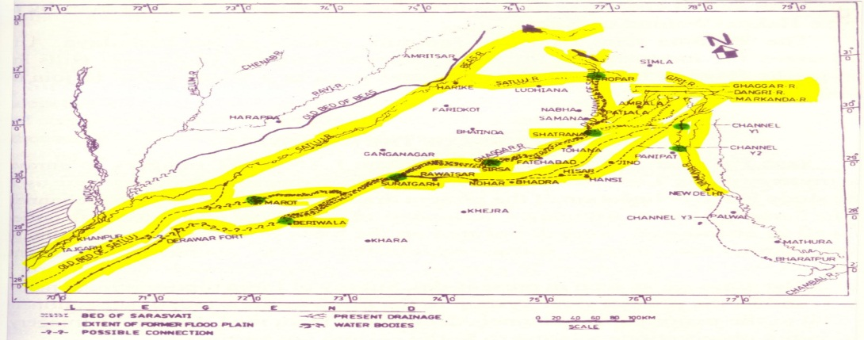
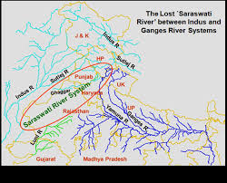
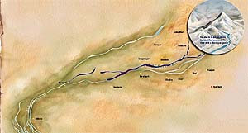

9.5 Archaeoastronomical record.

The Universe repeats itself, with the possible exception of history. Of all earthly studies history is the only one that does not repeat itself... Astronomy repeats itself; botany repeats itself; trigonometry repeats itself; mechanics repeats itself; compound long division repeats itself. Every sum if worked out in the same way at any time will bring out the same answer. ... A great many moderns say that history is a science; if so it occupies a solitary and splendid elevation among the sciences; it is the only science the conclusions of which are always wrong. (Chesterton 2011: 82)

Although Dr. Rao has done a good job in his field, despite his rejection of the dating of 3102 BC, is quite superficial and little hasty. Others conservative intellectuals of colonial müellereane and Aryan Invasion models had said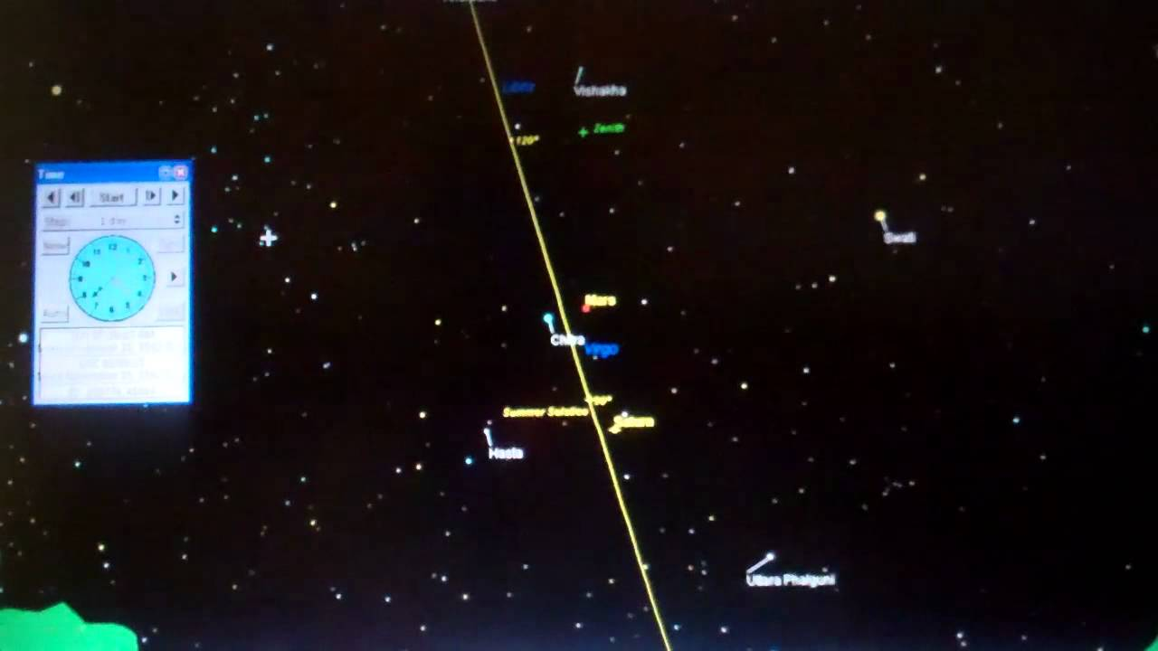

that around 5000 ago 3102 BC Kali-yuga’s beginning date was invented by Hindus astronomers in V AD that means 1500 years ago. But the reality is, that many astronomical references coming from ancient Sanskrit sources like Rig Veda, Brahmanas and Upanishads, Mahâbhârata and others old text, (See Arganis 2014) In recognition of ancient Hindu sages mathematics and astronomy, Sebokht, the Bishop of Qinnesrin in Syria 1500 ago in 662 AD wrote: “Indian Discoveries in astronomy were more ingenious that those of the Greeks or Babylonoians, and their numerical (decimal) system surpass descriptions. (Cit in Clarkl, 1929)

As it was said before, maritime archeology cannot be alienated from the whole body that constitutes anthropology. Because, the Kali yuga age beginnings date, is supported by astronomical findings with cutting-edge methodology, which constitutes the scientific discipline called archaeoastronomy.

9.6 Digital calculation of planetary configurations in Mahâbhârata
Archeoastronomy is the study of how people in the past have understood the phenomena in the sky, how they used these phenomena and what role the sky played in their culture history. Archaeoastronomy is also closely associated with historical astronomy, the use of historical records of heavenly events to answer astronomical problems and the history of astronomy, which uses written records to evaluate past astronomical practice. This discipline, uses a variety of methods to uncover evidence of past practices including archaeology, anthropology, astronomy, statistics. probability and history. Now we will look at some discoveries that have arisen in this field. The historian Juan de Dios Gonzales J., indicates The Christians chose the birth of Christ as the beginning of a New era; the Muslims, the Muhammad scape from Mecca (Hijra). From these [religious] events. Each civilization begins to count the years. [Gonzales 1994:12] Similarly, Teresa. E. Rohde reports that for historians, Hindus marked the beginning of a calendar age called Kali-yuga-from the death of Krishna. (Rodhe 1989:xi] the determination of the beginning of this Age, is a key clue to approach the possible dating. Since there were three calendar eras used in ancient India, 1) the Vikram Era (57 BC) and the 2) Shaka Era (78 BC), but the 3) Kali-yuga Age was first used, which was astrologically fixed 3045 years before was Vikram age; as recorded in the writings of the two aforementioned ages. Some epigraphic evidence corroborates this dating, such as the inscription of Pulakesin II, found in Aihole, also those discovered in the copper trays of Belgaum and in Nidhapur. Also the ancient sources, such as the Jyotirvidabharnamâ of Kalidas, The dynastic chronology of Nepal, The uninterrupted chronologies of the Hindu kings of the 4 dynasties that ruled Hastinapur up to King Vikramaditya, including the Arabic text Tahqiq-i-Hind, The Aryabhatiya, etc. confirm this date of 3102 B C that means 5000 years back for Kali yuga.
On this point, Dr. Howard J. Resnick of Harvard, has written that the famous astronomer Aryabhatta, who was one of the founders of trigonometry, wrote a book, considered as the Ephemerides till day, and which have been acknowledged for centuries recognized by European and Islamic scientists and mathematicians. Also the first Indian satellite, as well as a lunar crater, a University and a Scientific Institute were baptized with his name. In his celebrated work Aryabhatiya was one of the first to confirm the calculations for the astronomical references of the Mahâbhârata, reaching very approximate conclusions to the recent investigations. (Resnick 2015)
Dr. S. Balakrishna of NASA, USA; Dr. B. N. Narahari Achar, Department of Physics, Memphis University, USA; Dr. R. N. Iyengar, Department of Civil Engineering, Bangalore; Dr. S. Kalyanaraman, Sarasvati River Research Centre, Chennai and others submitted papers on the date of Mahâbhârata war based on Astronomical data with the use of Planetarium software at the two-day seminar in Bangalore, India between fifth and sixth January 2003 and agreed that there does not exist any contradiction between any two descriptions of planetary configurations given in the Mahâbhârata . ( Arganis, JAMMO Vol 2. Part :84-90 2011)
Dr. S. Balakrishna using the Lode Star software studied both the solar and lunar eclipses mentioned in the Mahâbhârata to find out the dates of the eclipses and found out that from 3300 B.C. to 700 B.C. almost 6000 solar and 4000 lunar eclipses occurred, but not all of them were visible from Kurukshetra. He discovered that 672 were eclipse pairs (solar and lunar) in one lunar month. However, it was the three out of the eight places where solar eclipses were mentioned that he found very important in relation to the account in Mahâbhârata: solar eclipses in Sabha Parva, Udyoga Parva and Shalya Parva. Many also believe that a total solar eclipse occurred on the 13th day of the War, which has been allegorically mentioned as covering the sun by Lord Krishna with His Sudarshan Chakra.
Three eclipses took place in a lunar month, which was a very rare incident before the Mahâbhârata War in the order of ―a lunar eclipse followed by a solar one and then another lunar eclipse. According to the text of, Mahâbhârata the solar eclipse occurred just 13 days after the first lunar eclipse. Dr. S. Balakrishna of NASA, USA, has searched all eclipse pairs, a lunar eclipse followed by a solar eclipse after 13 days that took place from 3300 B.C. to 700 B.C in other words 5400 to 2800 years ago. using the Lodestar pro-software. He found that nearly 672 eclipse pairs have occurred within the said period, out of which 27 pairs have been found to have less than 14 days time gap. According to Dr. Balakrishna, the eclipse pair of 2559 BC or 4600 years back is the best match with the description given in the Mahâbhârata . But according to Dr. Kalyanaraman, the eclipses occurred a little 5000 years ago in 3067 B.C.- the lunar eclipse on 29th September at the asterism Krittika and the solar eclipse on 14th October at the asterism Jyestha‖. (Idem) Researcher Dr. P. V. Holay examined 6 planetary configurations given in the Mahâbhârata and concluded that the War began on 13th November 3143 B.C. But Dr. K. S. Raghavan and his co-worker Dr. G. S. Sampath Iyengar, using the Planetarium software came to the conclusion that the Kurukshetra War began on 22nd day of November 3067 B.C. (according to the present Gregorian calendar). Professor Dr. Narahari Achar of the University of Memphis, USA, also arrived at the same conclusion using the said Planetarium software. Dr. S. Kalyanaraman of the Saraswati River Research Centre, Chennai, found the estimates of Dr. K. S. Raghavan and Dr. Narahari Achar correct and, on that basis, calculated the dates of some other important events of Mahâbhârata. For example: Krishna, on His final peace mission, set out for Hastinapur on 26th September, 3067 B.C. when the moon was at the asterism Revati. Sri Krishna arrived Hastinapur on 28th September 3067 B.C., when the moon was at the asterism Bharani. The full moon and lunar eclipse at Krittika occurred on 29th September 3067 BC this is 5000 years old (Idem)
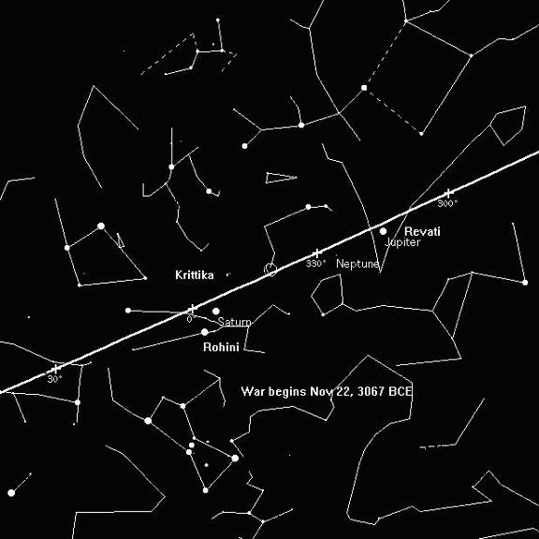

Table 1.a historical astronomy datations that holds 5 000 years back
The solar eclipse at Jyestha occurred on 14th October 3067 B.C.
Balarama set out for pilgrimage on 1st November 3067 B C
The War began on 22nd November 3067 B.C.
Balarama concluded His pilgrimage on 12th December 3067 B.C.
The winter solstice occurred on 13th January 3066 B.C.
Bhishma died on 17th January 3067 B.C.
The comet Mahaghora appeared at the asterism Pushya in October 3066 B.C.
The 2003 Bangalore seminar officially accepted that the Mahâbhârata War began on 22nd November 3067 B.C. (Idem) It thus appears that the Mahâbhârata War took place, not in Dwapara Yuga but in the 36th year of the present Kali Yuga. This is not unlikely given the text of Mahâbhârata, ―the War took place at the juncture of Dwapara and Kali Yuga. (Idem)
In 2005, astrologer Arun Kumar Bansal, using computer software, calculated the date of birth of Lord Krishna and arrived at five thousand years old 21st July 3228 B.C. But that is not the last, because Dr. Richard L. Thompson and Dr. Narahari Achar, proved with the last technology mathematical astronomical software, that Krishna‘s birth day constellations correspond to year 3167 B.C that means 5267 till to day. This makes the age of Krishna around 100 years during the Mahâbhârata War. However, in Hindu scriptures and other classic historical authors, even the Bible said the normal life span of human beings is many years in the past. (Idem) See :
Table 1.b
Krishna, in His final peace mission, went to Hastinapur in the month of Kartika. He set out on the day when moon was at the asterism Revati.
On His way to Hastinapur, Krishna took rest for a day at a place called Brikasthala, and on that day the moon was at the asterism Bharani.
The day, on which Duryodhana turned down each and every effort of Krishna to make peace and made the war inevitable, the moon was resting at the asterism Pushya.
Sri Krishna left Hastinapura with Karna, on the day when the moon was yet to reach the asterism Uttara Phalguni.
It is also well known that during the War, Lord Balarama went on a pilgrimage to holy places along the banks of the River Sarasvati and Mahâbhârata describes the position of the moon during the entire course of pilgrimage. For example, He set out on the day when the moon was at the asterism Pushya and returned on the day when the moon was at the asterism Shravana.
The Mahâbhârata also mentions the occurrence of a solar eclipse at the asterism Jyestha and a lunar eclipse at the asterism Krittika, just before the beginning of the War.
It also mentions the appearance of a comet at the asterism Pushya, on the 8th day of the bright half of the month of Magha, when Bhishma died. On that day the moon was at the asterism Rohini and it was the day of Winter Solstice.
The day on which Ghatotkacha, son of Bhima, died, the moon appeared at the horizon at 2.00 a.m.
The epic also mentions the occurrence of a very rare astronomical event that took place prior to the War: three eclipses, two lunar and a solar, within a lunar month of 27 days.
There is also another continuing tradition in India that says that the beginning of the present Kali Yuga, Kurukshetra War, departure of Lord Krishna and coronation of Emperor Yudhishthira were contemporary events.

9.7 There is other evidential archeoastronimical factor, in the main work on Krishna’s life- Bhâgavata Purana. is mentioned that the Polar star called Dhruvaloka was the fixed star in the center of the Polar Axis, and according to modern astronomical studies, the Polar star was not in that position since 1500 BC till to 1000 CE, but rather in a period before 4700 years in the past 2600 BC. Such Polar star was Thuran or Alpha Draconis. That indicates that the constellation called Sisumara must have been in that alignment in much more remote times, when the Polar star was Dhruva or Thuran, in fact all astronomical evidence record inside this Puranic text show:. The stellar mentions percentages vary in each Canto although a proportional tendency is seen of 50 to 75% in some Cantos in favor of the cosmographic model called Bhumandala. Parallel models are found in other cultures both in Asia and in America, which suggests that it was widely accepted in a period before the Ice Age. Also, although in a lesser degree, there are mentions of the seven-planetary system, the constellation called Sisumara, the constellation of the Seven Rishis (the Great Dipper), the astronomical model of the Jyotir Veda, the conjunction of the star Rohini or Aldebarán (Alpha Tauri) that is dated around 5000 years in 3167 BC, together with the concept of the Milky Way as a Heavenly River and the system of Nakshatras or lunar mansions, all of which found parallels in China and Egypt, around 4000 and 5000 in 3000- 2000 BC. The highest percentage of stars mentioned in this narrative is 97.5% in favor of Dhruvaloka as the Pole Star, how already had said: it was known as Thiuran or Alpha Dacronis up to 4700 years ago in 2600 BC, and absent from then on until 700 years ago, the 14th century CE.
These references do not correspond to the period of 1500 or 1000 BC or 3000 years back. And neither for the first millennium of the Christian Era, since the Hindu astronomers of this period, state that the puranic model contradicts their astronomical observations. (Thompson 1991) This means that the astronomical observations in the Bhâgavata-Purâna coincide with the age of the Mâhabhârata and other archaic cultures.

9.8 In 1991, Dr. D. Abhayankar and Dr. Ballabh of the Osmania University calculated that the present Kali Yuga began on 17th February 3104 B.C. However, it is now the accepted norm for both the Eastern and the Western scholars that the present Kali yuga began on the midnight of 17th and 18th February 3102 B.C. One can therefore surmise that the Mahâbhârata War took place nearly 5000 years ago. Dr. Richard L. Thompson proofed with the last technology mathematical astronomical software, that:

TABLE 2 The Celestial Longitudes of the Planets at the Start of Kali-yuga
Planet Modern Mean Longitude Modern True Longitude
Moon -6;04 -1;14
Sun -5;40 -3;39
Mercury -38;09 -19;07
Venus 27;34 8;54
Mars -17;25 -6;59
Jupiter 11;06 10;13
Saturn -25;11 -27;52
Râhu -162;44 -162;44

This table shows the celestial longitudes of the planets relative to the star Zeta Piscium (RevatÈ in Sanskrit) at sunrise of February 18, 3102 B.C., the beginning of Kali-yuga. Each longitude is expressed as degrees; minutes. (Idem )

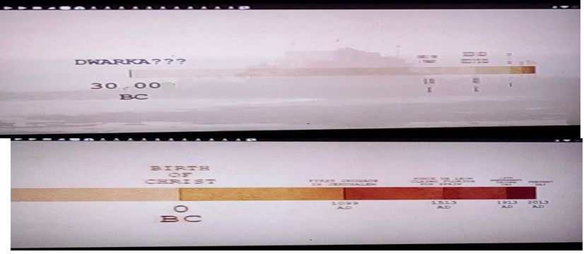

Conclusion
Arriving at the end of this study, undoubtedly, jumping to the conclusions immediately, without a thorough study of all the evidence analyzed and presented here, is a graphically vicious defect, when it is a legitimate questioning that refutes and deconstructs a paradigm so ingrained, as is the case presented here. Therefore, only and unless that more findings and hard evidence are discovered that direct the search in another direction; the proofs points to the following conclusions:
- It has been shown how experts accentuate, archeology being a branch of anthropology, cannot be studied in isolation, from the entire interdisciplinary body that composes and assists this field of scientific knowledge.
- The scientific credentials of the discovery of Dwaraka, are quite rigorous and were recognized by various authorities on the subject and even published and referred to in specialized journals and academic books and its impact reached worldwide by TV documentaries of scientific divulgation.
- Therefore, to day when ethnic cultures, aboriginal people, indigenous people, cultures of resistance are reconsidered in a new light by individuals, Human Rights groups, the ONU, UNESCO and even in beginning of this decade 2010’s, the Nations of America that celebrated their bicentennials of Independence like Mexico, which obviously exalts with a legitimate right the national sense, that tries to find in it what the society and culture of the "first world" denies, hides or distorts. In such a historical-social context, a neutral and rigorous exploration is required, as is the tentative in this research. At present, in the First World countries, there are criminalizing laws for the mistreatment of domestic and wild animals. These entail severe penal sanctions, such as deprivation of liberty, high bail payments, etc. The same is the case with the cutting trees what can one said about to injury of Cultural Ruins, ethnical groups, etc… People find in religion a means of physical, mental, emotional and existential improvement. But political motive rhetorical mercenaries and some jacobines scholars in India, have ignored evaluating the risk and damage they cause in conducting their pirronical claims. So, where is a code of ethics or bioethics that governs social studies on India culture and religion? Everyone has been terrified by the Taliban's vicious attacks on Buddha statues in Afghanistan, but the vandalism created by the Jacobin discourse is even more dangerous and horrific, because this threaten the integrity of 1700 billons of Hinduist people around the world and misleads to innocent people. In this regard, the Nobel Laureate Physicist Wolfgang J. Pauli advertised to all the scholars:

We may well reach the point in the not too distant future where the parables and images of the old religions will have lost their persuasive force even for the average person; when that happens, I am afraid that all the old ethics will collapse like a house of cards and the unimaginable horrors will be perpetrated. (Wolfgang, 1958)

In fact, the faked of this atheistic believed had been debunk by Sermonti, G. crepuscolo dello scientism (twilight of scientism) Milán 1971 and Shermer, Michael. "The Shamans of Scientism." Scientific American June 2002. And other Physicist from Zurich University, Walter Heitler confessed in his book Man and Science, the implications of this jacobine ideology, whether communist or scientistic atheist - mechanistic cosmovision:

Belief in a (pirronic) mechanistic universe is a modem superstition. As probably happens in most cases of superstition, the belief is based on a more or less extensive series of correct facts, facts which are subsequently generalized without warrant, and finally so distorted that they become grotesque… The witch superstation cost innumerable innocent women lives, in the cruelest fashion. The mechanistic superstation is more dangerous. It lead to a general spiritual and moral drying-up, which can easily lean to physical destruction. When once we have go to the stage of seeing in man merely a complex machine, what does it matter if we destroy him? ( Heitler. 1963:97)

This was historically demonstrated with the tyrannies in the Jacobin France Terror’s Regimen and even worse communist leaders in the countries conquered by them, with their own people. They greatly surpassed the Nazi genocides and the Inquisition. So, every man really thinker and sensitive, should deeply consider the following implications that ready pointed, like Professor Michael J. Bazyler warned, just changing the words Nazi by Marxsim- atheistic -communism

As a result of the enormous suffering inflicted upon the world by the Nazi regime, and especially Europe, a number of European countries have enacted laws criminalizing both the denial of the Holocaust and the promotion of Nazi ideology. The aim of these laws is to prevent the resurrection of Nazism in Europe by stamping out at the earliest opportunity – or to use the phrase “to nip it in the bud” – any public reemergence of Nazi views, whether through speech, symbols, or public association… Presently, the following European countries have some legislation criminalizing the Nazi message, including denial of the Holocaust: Austria, Belgium, the Czech Republic, France, Germany, Liechtenstein, Lithuania, the Netherlands, Poland, Romania, Slovakia, Spain and Switzerland. Holocaust denial is also illegal in Israel. (Bazyler 2019)

Definitively discovery of Krishna ‘s Dwaraka has been victimized by the reactive and toxical political environment of contemporary India country. The scientific discoveries and the cultural religious heritage of India, should be fully out site of the purview of political manipulations, more well is a humanity patrimony and the UNESCO and other International federations and Science Academies how Great World Potencies like USA, etc., should fight to protect this and others Cultural human legacy. And put great sanctions to everybody that try to attack or violate this Great Human patrimony. The Cultural Religious patrimonies are the people treasury and should not be used by any politic party or any political ideology.

- It has been demonstrated in a diachronic way, with solid historical evidence ( ethonographic, documentary, epigraphic) which demonstrate the identification of the submerged city of Dwaraka, as the authentic place founded by Krishna.

- Several finds have been reported in the Bay of Dwaraka in surrounding areas, by marine archeologists, which includes ceramics, ruins of construction, Demonstrate that there was a large settlement, which tend to coincide with the descriptions and topography as the historical geography given in the puranic and Mahâbhârata narrative of the city founded by Krishna, Dwaraka.

- Although undoubtedly the origin of such one Indo-European community in itself, is something that in the present is outside the scope of scientific knowledge, the truth remain ignored. However, the Múeller chronological model is never was subject to rigorous validation beyond the field of historical linguistic and speculative grounds. This model was used to interpret archeological materials as well, which in turned were used to time’s reconstructions; but without conclusive evidence. The same problem is applicable to dating the 10th century BC to Mahâbhârata age. Because the date of 500 BC to Buddha is non-conclusive, and there is a clear misidentification of Sandracutus with Chandragupta .Maurya, it has been clearly demonstrated how the only plausible identification is with Chandragupta Gupta. (for a full demonstration of this issue see. 13.Chandragupta, the Sandrocottus in Gokhale 1998)

- The seals of Mohenjo Dharo and Harappa are similar to found in Dwaraka, which coincide with those mentioned in the Harivamsa. The pottery that contains characters are similar to those of the Cultures of the Hindu. In short, even an archaeologists with a strong Jacobin tendency have recognized that the oldest finds in Bet Dwaraka date back to 3000 BC., and this site was also associated with Krishna’s Dwaraka. And other relevant discovery that Krishna and Dwaraka´s times coming from this 3000 BC is a tablet found in the Mohenjodaro sites, depicts Krishna like baby Damodara releasing the Kuvera ‘s sons and is dated to be 2600 B.C

- There are diverse archeological discoveries around the North India Mâhâbharata areas, that the more ancients relics, remnants of weapons, that throw dates that come from 2800 BC almost 5000 years old in Kuruksetra, even dated by thermoluminescence method.

9) The discovery of Khambat Gulf gives more evidence of ancient society in Gujarat ‘s shore Arabian sea that was sunked in ancient times between 7000 to 12000 years ago, surrounding the ancient Dwaraka, but the traditional chronics indicate that Dwaraka was reclaimed from sea by Krishna. That means Dwaraka was foundering after Khambat ruins in ancients times. The discovery of the second exploration at Gulf of Khambat proves that it was not just Dwaraka that got submersed, but more costal regions got encroached by the sea over centuries, and this phenomenon took over the city of Dwaraka around 5000 years back 3000 BC.

- The Sarasvati river studies show that the timeline of Dwaraka cannot be 3600 years old, in 1500 BC, because this river dried nearly 4000 years in the past on 1900 BC and it was flowing with all its shrines before that, as is described in Krishna life sources … Based on the correlation between the excavated structures and artifacts with the description of Dwaraka in Harivamsa purana, etc., and the fact that even the carbon 14 and thermoluminescence dating of some artifacts fall around 5000 years ago since 2000 to 3000 BC. Over 1000 archaeological sites have been found on the course of this river and they date from 5000 old in 3000 BC. One of these sites is the prehistoric town of Kalibangan in northern Rajasthan.

- With respect to astronomical evidence, Neil de Grasse Tyson, did the follow memory:

Of all the sciences cultivated by mankind, Astronomy is acknowledged to be, and undoubtedly is, the most sublime, the most interesting, and the most useful. For, by knowledge derived from this science, not only the bulk of the Earth is discovered; but our very faculties are enlarged with the grandeur of the ideas it conveys, our minds exalted above [their] low contracted prejudices." James Ferguson, 1757. (Tyson, 2017 )

So, the evidence of the astronomical references in the texts that register the epoch constitutes a rich source to approximate through quantitative calculations, for the times of said events. The rigorous star map calculation contained in the main sources, dealing with the time of Krishna’s Dwaraka , performed by computer-based mathematical analysis, indicate with high precision the dates when the events happened, and show that it tends to an 5000 years age of 3000 years BC, which coincides with the oldest relics found in the excavations of Dwaraka and its surroundings archeological sites, associated with early Hindu’s cultures.

- Although the whole body of historical evidence (ethnography, documentary, epigraphy, archeology, etc.) rigorously demonstrates, the re-discovery of Dwaraka the Capital of Krishna. However, it is limited to this. And it does not justify any speculations of the ideology of extremism and intolerance of Indian chauvinism or patriotism; much less lends itself to the alienating and delirious phrases of the historical denial from modernistic Christian and atheist militants spokesmen. Also, this discovery doesn’t prove any legend like Daniken’s style ancient astronauts extrapolated theories. Dwaraka is Dwaraka, the great capital restored by the celebrity of Vâsudeva Krishna, the prince of the Yadavas

13), It is indeed surprising that the history associations, archaeologists and historians have taken little notice of the findings at Dwaraka. In its early days, the project received UNESCO support and several foreign marine archaeologists also offered help. However, the government's indifference to the project has kept them away. Unlike several other land excavations, the underwater excavations can be done only with total government help. Several levels of permissions are needed. While land excavations are demanding in labor, the underwater explorations need machinery and equipment. Skillful divers, who are trained to look for meaningful objects are required too.

14), For human Sciences, Dwaraka is not a mere archaeological site. But the excavations are a human heritage, a symbol for humanity an honor that is shared by all who are born in this planet.

15), For a more complete demonstration of the points established here, researchers can do a deep study of the book, Krishna and Indological Studies. An Epistemological Review. LAP LAMBERT Academic Publishing (2018-04-23) . ISBN 978-613-9-58708-7. which presents the author's research for several decades. https://www.morebooks.shop/store/es/book/krishna-and-indological-studies/isbn/978-613-9-58708-7.

Bibliography
Adwani, H. S. et Raveendra, M. A. Sunked City of Dwaraka. Vision World Bengalore India 1988. URL: https://www.youtube.com/watch?v=Zc2dWngyZH4&t=1446s

Ali, S. M. in Lord Krishna existed. School text are Wrong. URL:
http://www.hinduwisdom.info/Dwaraka.htm#Lord_Krishna_existed._School_texts_are_wrong_)T

Arganis-Juarez. Horacio Francisco. Lord Krishna Recognized by Scholars Long Time Ago, exhibited in the cyber Journal JAMO Vol 2, No 6 (2011) Vol 2: 6. 81-92. 21 August 2011

Arganis-Juarez, Horacio Francisco. What is the Antiquity of the Srimad- Bhagavatam or Bhagavata-purana of Classical Literature of India? in the Global Journal of HUMAN-SOCIAL SCIENCE: A Arts & Humanities – Psychology Volume 14 Issue 2 Version 1.0 Year 2014in the Global Journal of HUMAN-SOCIAL SCIENCE: A Arts & Humanities – Psychology Volume 14 Issue 2 Version 1.0 Year 2014

Arganis-Juarez Horacio Francisco. Krishna and Indological Studies. An Epistemological Review. LAP LAMBERT Academic Publishing (2018-04-23) . ISBN 978-613-9-58708-7.

Arya, Ravi Prakash. New Discoveries About Vedic Sarasvati. Copyrighted material. Vedicscience. ISBN 81-87710.69-1, India. 2014. URL: https://www.amazon.com/New-Discoveries-About-Vedic-Sarasvati/dp/8187710691

Bahn, Paul, and Colin Renfrew, Archaeology: Theories, Methods and Practice. New York, NY: Thames and Hudson, 2008. ISBN 978-0500287132

Bhaktivedanta, Swami. Srimad Bhâgavatam of Krishna Dvaipanaya Vyasa. Bhaktivedanta Books Truths. URL: https://www.vedabase.com/en.

Baladeva Vidyabhusana, Govinda-bhasya, commentary on the Vedanta-sutra. Krsna Institute, 1992.

Bazyler, Michael J. Holocaust Denial Laws and Other Legislation Criminalizing
Promotion of Nazism. URL: https://www.yadvashem.org/holocaust/holocaust-antisemitism/holocaust-denial-laws.html 2019.

Clark, W. E. Indian Studies in Honor of Charles Rockswell. Harvard University Press, Cambridge, MA 1929

Cremo, Michael A. at Thompson , Richard L. Forbidden Archeology: The Hidden History of the Human Race. San Diego: Bhaktivedanta Institute. ISBN 0‐9635309‐8‐4. 1998.
Chesterton, G. K. In 'A Much Repeated Repetition', Daily News (26 Mar 1904). Collected in G. K. Chesterton and Dale Ahlquist (ed.), In Defense of Sanity: The Best Essays of G.K. Chesterton (2011).

Editor. Tasmania Times. (2011). URL: https://tasmaniantimes.com/2011/01/the-lost-city-of-dwarka-rewriting-our-common-history-go-jimboooooooooooo/
Gambiranda, Swami. Bhagavad-Gita trans. Commentary by Sankaracharya. Vedanta Press. Kolkata: Advaita Ashrama August , 1984.
Gautier, F., (2008), A New History of India, Har Anand Publications, India.
Gaur, A., Tripathi S., (2005), Ancient Dwarka: Study Based on recent Underwater Archeaological Investigations, Migration and Diffusion, Vol 6, No 21, 2005.
Gaur A, Suderesh, S. Trpati. CURRENT SCIENCE, VOL. 86, NO. 9, 10 MAY 2004. URL : file:///C:/Users/USUARIO/Downloads/Curr_Sci_86_1256.pdf

Gaur, A.S. and Vora, K. H. Underwater Cultural Heritage.. Current Science Volume 86 No 9 May 2004.

González Jiménez, Juan de Dios. Historia. 1er. Curso. Editorial Santillana. S.A. de C.V. México D. F. 1994, p. 12.
Goswami, Jiva. Krishna Sandarbha. An Essay on Lord Krishna. Vol. 6. The Krishna Library Vol. 49. Tr. Kusakratha dasa. Los Angeles USA. 1989.

Hari D .K. and D.K. Hema Hari, Historical Krishma. Proving Historicity of Krishna. Founders, Bharath G Gyan 2017.. URL:
https://bharathgyanblog.files.wordpress.com/2017/07/historicalkrishna1.pdf

Heitler, Walter. Man and Sciencie. New York Basic Books. 1963.

Heldaas. Seland , Eivind. Archaeology of Trade in the Western Indian Ocean, 300 BC–AD 700. December 2014, Volume 22, Issue 4, pp 367–402 .URL:
https://link.springer.com/article/10.1007/s10814-014-9075-7Journal of Archaeological Research.

Khonde, Nitesh. Present address: Birbal Sahni Institute of Palaeosciences, Lucknow, 266007, India 2019.

Krishna, Nandita. (2003) Krishna Archeolgy. URL: http://veda.krishna.com/encyclopedia/krishna-archeology.htm

Lamnbour, India from Aden – Khutba and Muslim Urban Networks in Late Thirteenth-Century India ;70 1992)

Sundaresh Gaur, A.S. Vora, K.H. Tripati, S. et al. " Some new thoughts on the discovery of ancient Dwarka: A study based on recent marine archaeological exploration off Dwarka, West Coast of India [2005]

Ernest J. H. MacKay. Mackay’s report, Part I, pp-344-45, Part 2, plate no. 90, object no. D.K. 10237 See Mackay Indus Civilization. Ams Pr Inc (1 de junio de 1983)

Mahâbhârata. Critical edition. Bhandarkar Oriental Research Institute. April 1919 to September 1966.

Müeller, F. M. (1883). India: What Can it Teach Us? London: Longmans, Green, and Co. p. 21
Müeller, F. M. (1869). Chips From A German Workshop. New York: Charles Scribner and Company. Vol. I. URL:

http://www.gutenberg.org/files/24686/24686-h/

Müeller, M. (1899). The Six Systems of Indian Philosophy. London: Longmans, Green.
New Indian Press. 2018. URL: http://www.newindianexpress.com/lifestyle/spirituality/2018/aug/12/the-mythical-city-of-dwarka-1855600.html.

Parkin; David and Ulijaszek Stanley. Holistic Anthropology: Emergence and Convergence. Article in Journal of the Royal Anthropological Institute 16(1):200-201 · January 2010 with 23 Reads. DOI: 10.2307/
Pauli. Wolfgang J. (1958): URL (http://www.greatthoughtstreasury.com/author/author-180)

Prasad Gokhale. Antiquity and Continuity of Indian History. (From Swayambhuva Manu to Gupta Dynasty). University of New Brunswick. 1996. URL:
https://www.academia.edu/38289050/Antiquity_and_Continuity_of_Indian_History.docx

Preciado, Solís, Benjamín. Primeras evidencias históricas sobre Kŗşņa. Printed by Estudios de Asia y Africa, vol. XV, nº 4. El Colegio de México, 1980.

Rao, S. R., (1999), The Lost City of Dwarka, National Institute of Oceanography, India The Mahabharata.
Rao Dr. S. R. Dwarka to Kurushetra.. Journal of Marine Archaeology (1995-96).

Rao Dr. S. R. Further Excavations of the Submerged City of Dwarka. S. R. Rao. Recent Advances in Marine Archaeology News Articles (Hindu, Deccan Herald, Reuters). http://rafalreyzer.com/the-underwater-ruins-of-dwarka/ 2010
Rao, S. R. Science and Technology behind Mahâbhârata (2014). URL http://maabharathascience.blogspot.com/p/30-underwater-expeditions-which-won-rao.html

Resnick, Howard J. A Comprehensive Guide to Bhagavad-Gita with Literal Translation. Krishna West Inc. USA 2015.
Rohde , Teresa E. Introduction to Valmiki, El Ramayana. Colección Sepan Cuantos No. 190. Editorial Porrúa. México. 1989.

Rosen, S. J Archaeology and the Vaishnava Tradition: The Pre-Christian Roots of Krishna Worship. Firma KLM 1989.

Rosen, Steven J. Vaisnavism. Cotemporary Scholars Discuss the Gaudiya Tradition, Folk Books, New York, 1992. and Motilal Banarsidass; 2nd edition (January 1, 1998).

Russell, R. V. 1916. Rajput: Yadu, Yadava, Yadu-BhattiJadon From The Tribes And Castes Of The Central Provinces Of India. URL: http://indpaedia.com/ind/index.php/Rajput:_Yadu,_Yadava,_Yadu-BhattiJadon

SERMONTI, G. crepuscolo dello scientismo, Milán 1971.

Shermer, Michael. "The Shamans of Scientism." Scientific American June 2002.

Swami , B: B. Vishnu M. S.. Scientific Verification of Vedic Knowledge, Devavision. India 2005.

Tagare, Ganesh Vasudeo. The Bhâgavata-Purâna. Montilal Banarsidass. Delhi India. 1986, p. xxxv-vi

Thompson R. L. Vedic Cosmography and Astronomy. The mysteries of the Fith Canto of Srîmad-Bhâgavatam. The Bhaktivedanta Books trust. USA. 1991.

Thompson R. L . Reflections on the Relation Between Religion and Modern Rationalism. > ICJ Vol 1, No 2 December 1994. Rational "Mythology", URL: http://content.iskcon.org/icj/1_2/12thompson.html.

Thompson Richard L. Mysteries of the Sacred Universe. The Cosmology of the Bhâgavata Purâna. Goverdhan Hill Publishing. Alachua, Florida 2000

Tod, James & Crooke William. Annals and Antiquities of Rajasthan; or the Central and Western Rajput States...– abril, 1998.

Tyson, Neil de Grasse. Astrophysics for People in a Hurry. W. W. Norton Company, May 2nd 2017.

Videopostman, (2011) URL: https://www.youtube.com/watch?v=nQZFS9Hij0M

Samira Sheikh.State and Society in Gujarat, c. 1200-1500: The Making of a Region Thesis submitted for the degree of Doctor of Philosophy Faculty of Modern History, Oxford University Michaelmas Term, 2003. URL:
https://ora.ox.ac.uk/objects/uuid:9d9736d6-dc29-4911-833d-30786199a3f/download_file?safe_filename=602157144
.pdf&file_format=application%2Fpdf&type_of_work=Thesis

van Buitenen, J.A.B. On the Archaism of the Bhagavata Purana, pp. 23-40, in Krsna, Myths, Rites, and Attitudes, Edited by Singer, M., U. of Chicago Press, 1966.

Vora, Kamalesh H. 2019. URL: https://uns-id.academia.edu/KamleshVora .

Vora*, K. H., A. S. Gaur*, David Price‡ and Sundaresh*. Cultural sequence of Bet Dwarka island based on thermoluminescence dating *National Institute of Oceanography, Dona Paula, Goa 403 India 2004.

https://www.speakingtree.in/allslides/the-city-of-dwarka-had-existed-from-32-000-to-9-000-bc/share-it FEB 11, 2016 06:01PM

Fomenko T. THE PROBLEMS AND DEFICIENCIES OF DENDROCHRONOLOGY AND SEVERAL OTHER DATING METHOD . Anatoly History or Science?

Appendixes

Biography and career
Dr. Rao completed his education from Mysore University. He worked in the Archaeological Department of Baroda State and subsequently served the Archaeological Survey of India in various capacities. Rao has led excavations of many important sites such Rangpur, Amreli, Bhagatrav, Dwarka, Hanur, Aihole, Kaveripattinam and others. One of his most important works were leading the research and excavations at Lothal, the earliest known port in history and the most important Indus-era site in India. Rao was the recipient of Jawaharlal Nehru Fellowship and a doctorate of literature from Mysore University. Rao had supervised excavation of several historic sites across the country in the West and South. He was also associated with conservation of monuments such as Taj Mahal and forts. Despite officially retiring in 1980 Rao was requested to work for the ASI Director General in leading Indian archaeological projects. It was under Rao's initiative that the NIO opened a marine archaeology research centre in 1981, under the stewardship of then director Syed Zahoor Qasim, which grew into a world recognized body. He was the founder of the Society of Marine Archaeology in India. Rao has been at the forefront of Indian archaeology for many decades - he was involved in extensive research into India's ancient past, from the sites of the Indus Valley Civilization to excavations pertaining to the Kurukshetra War.

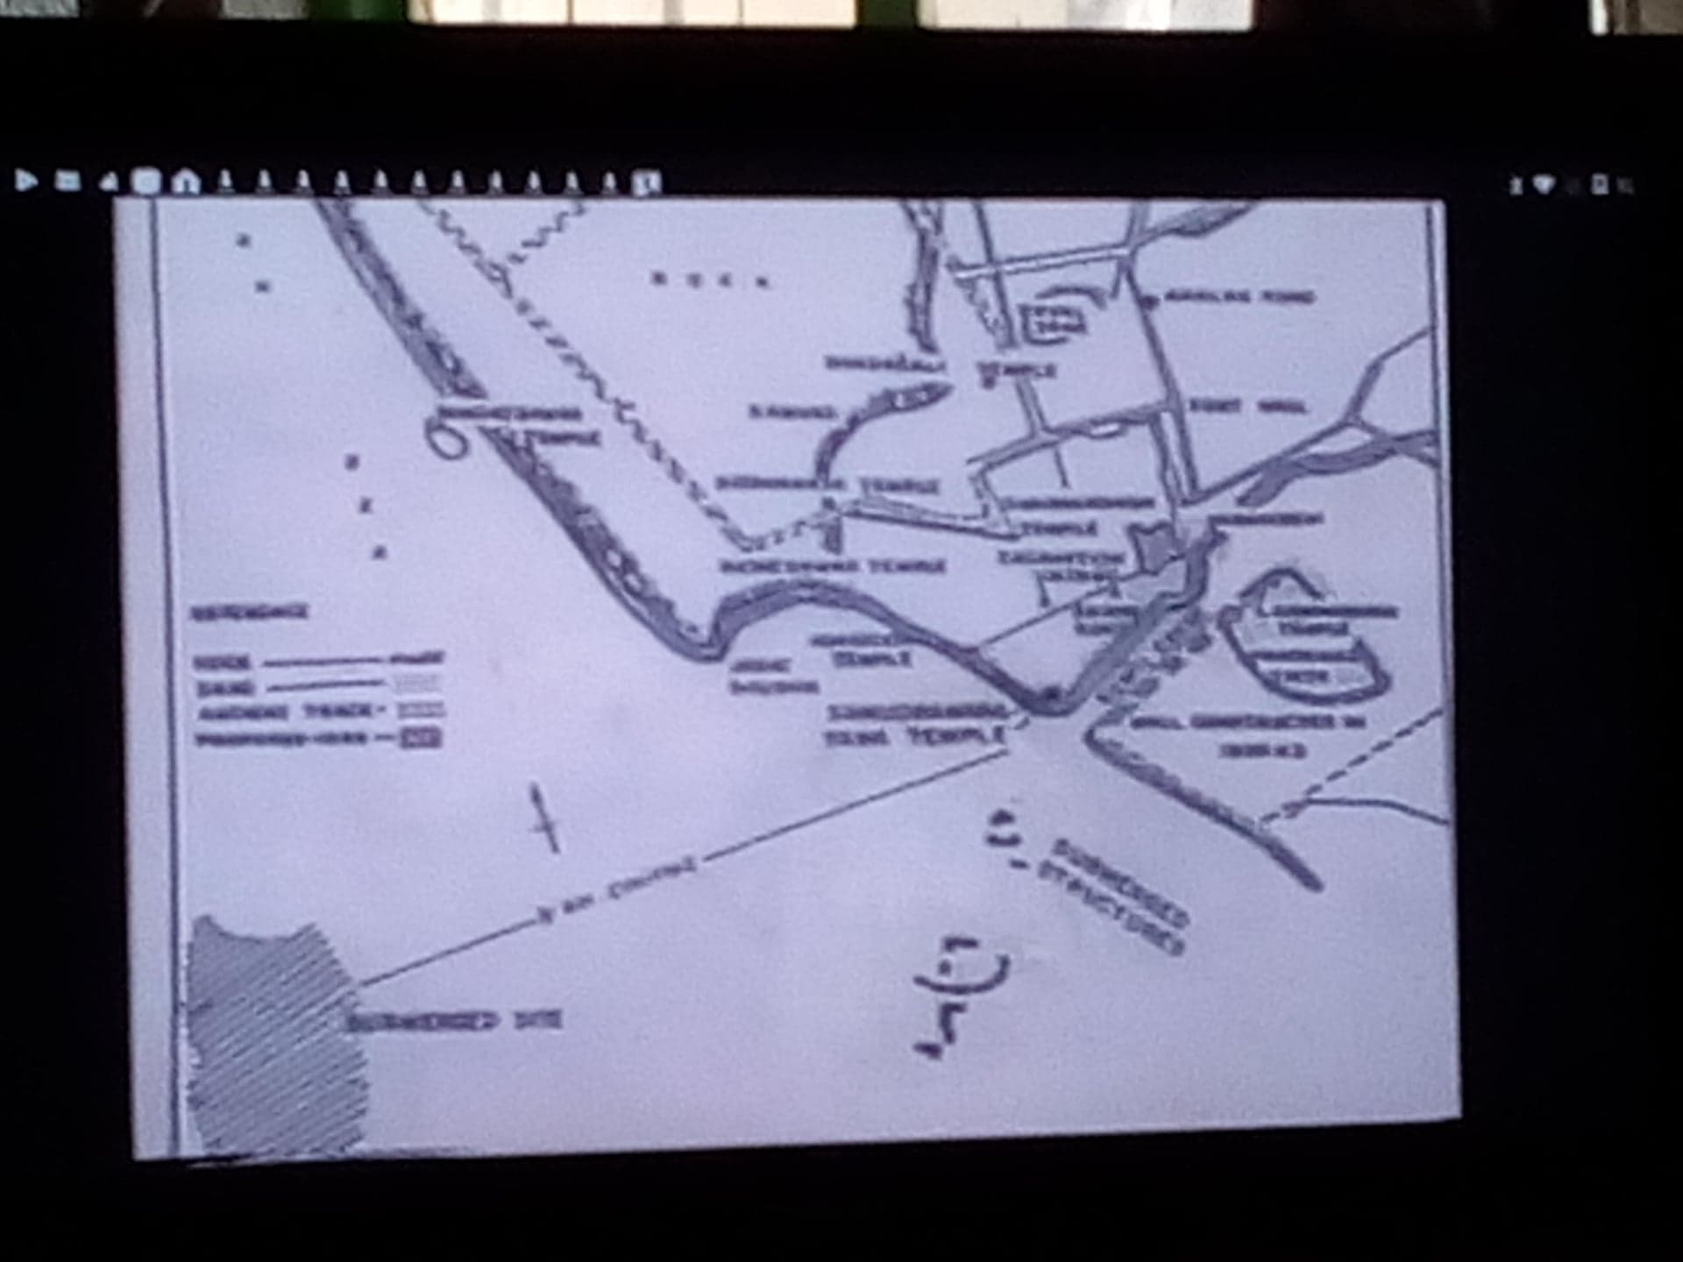
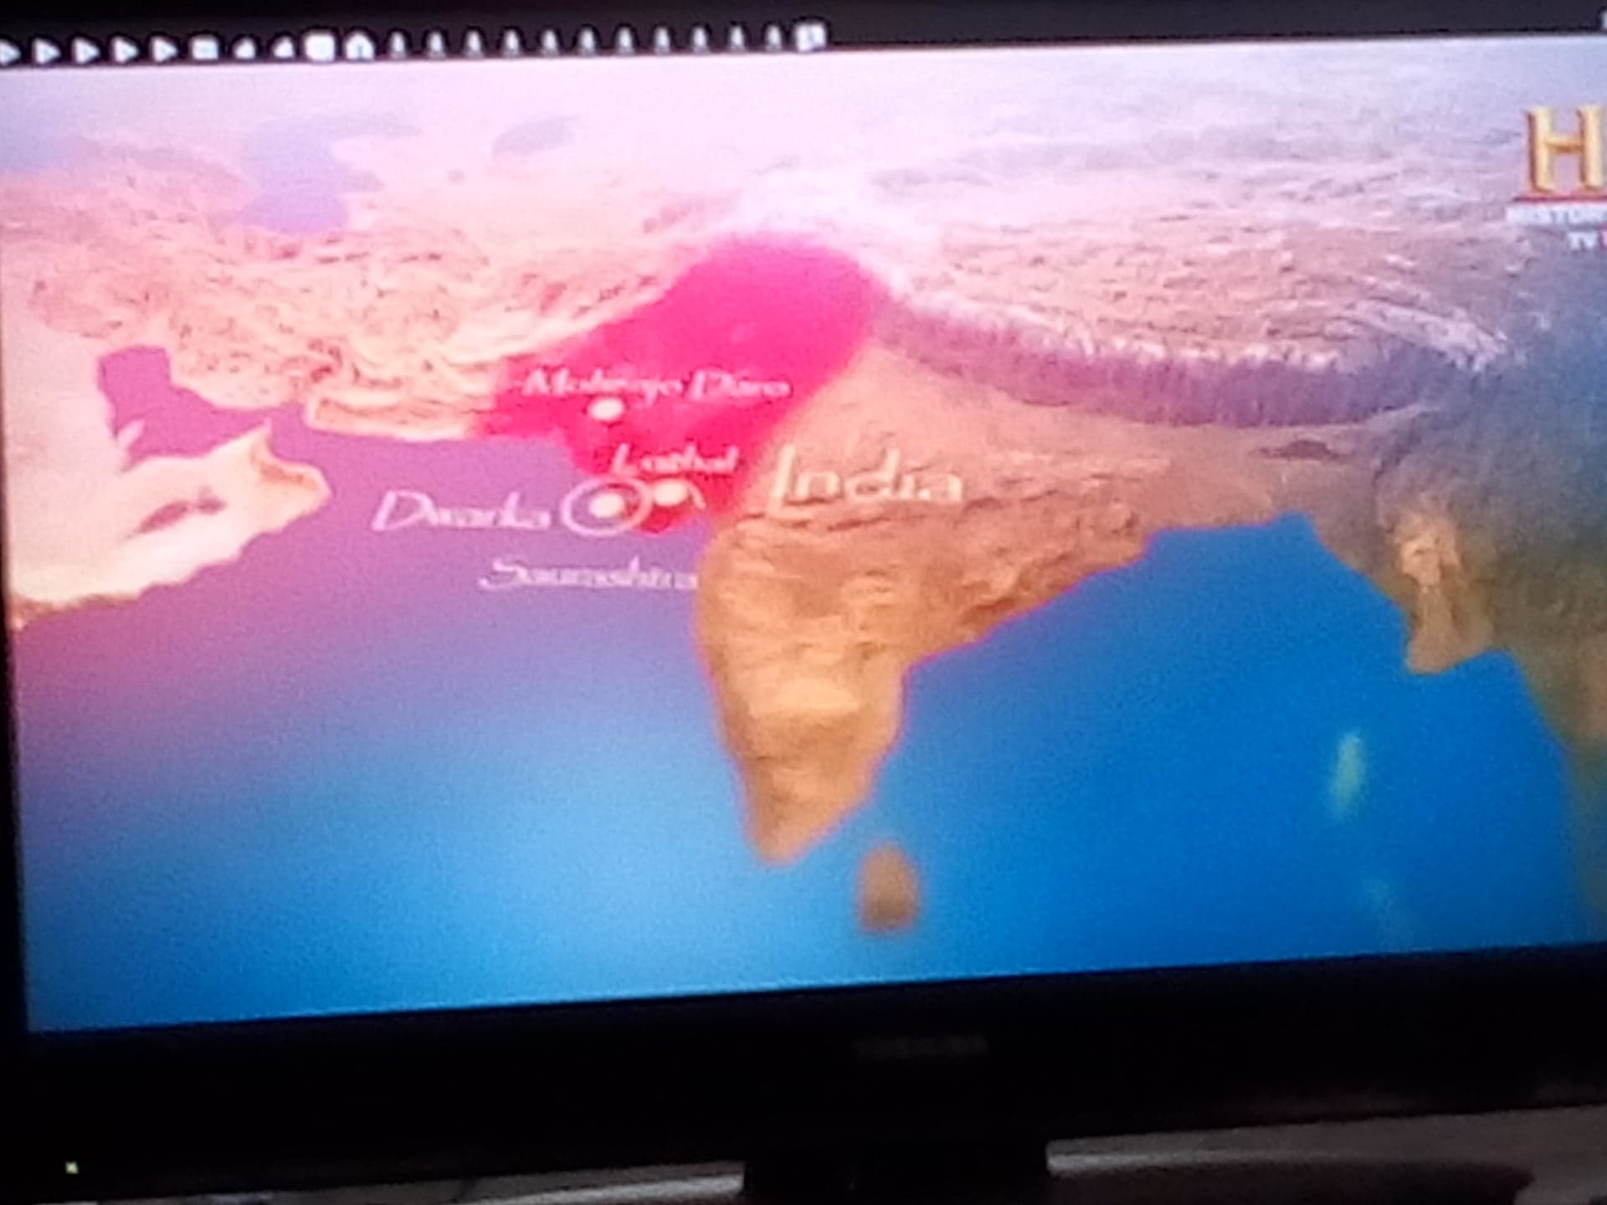
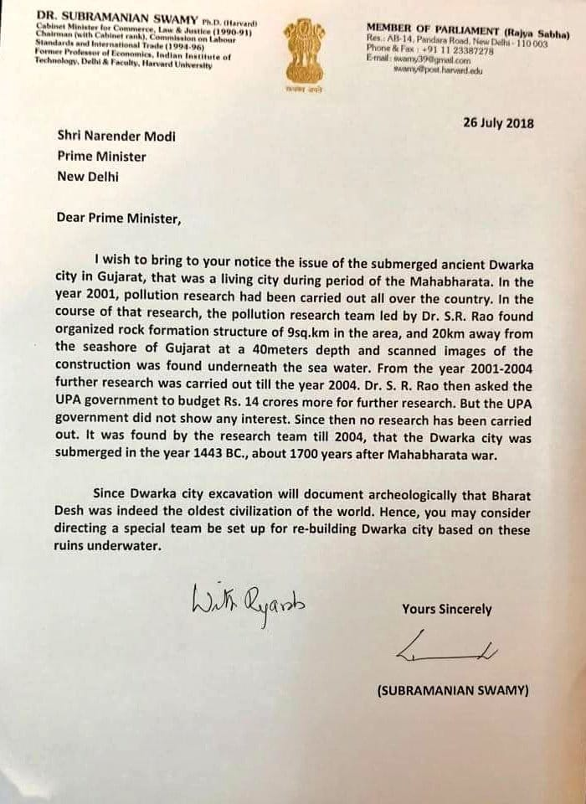
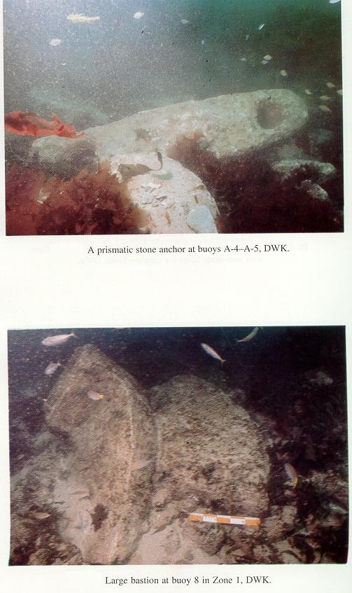
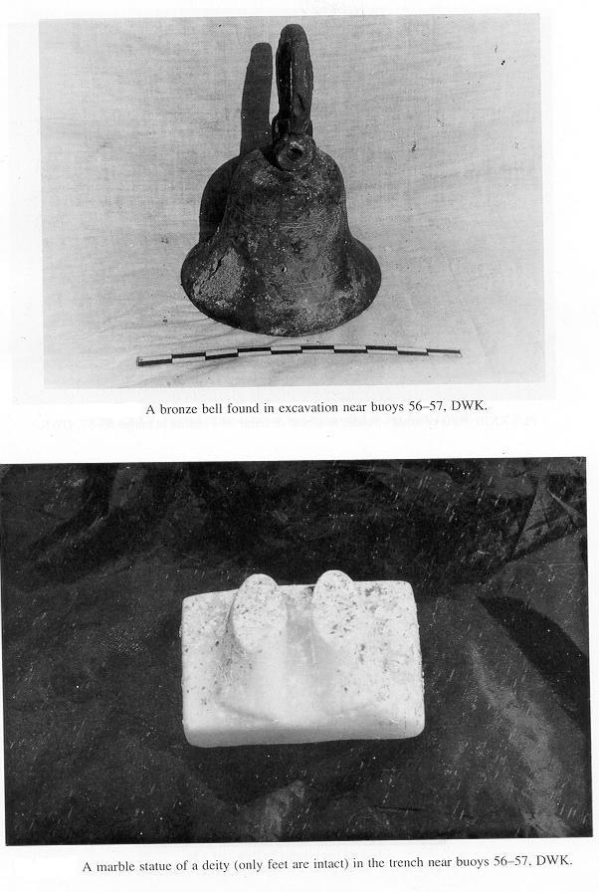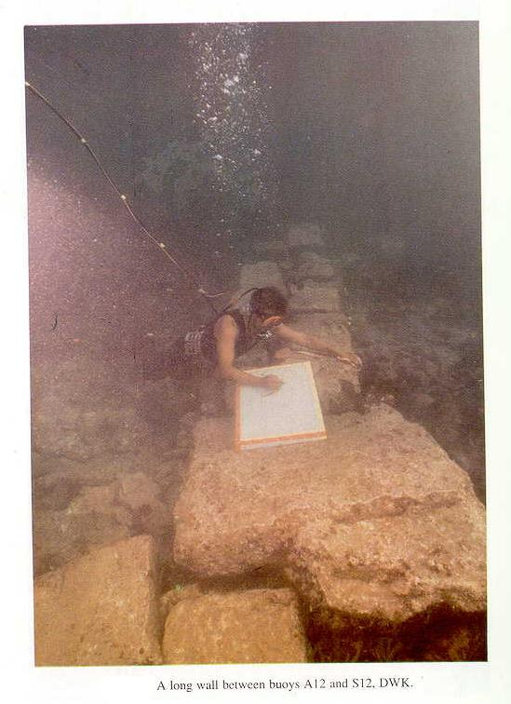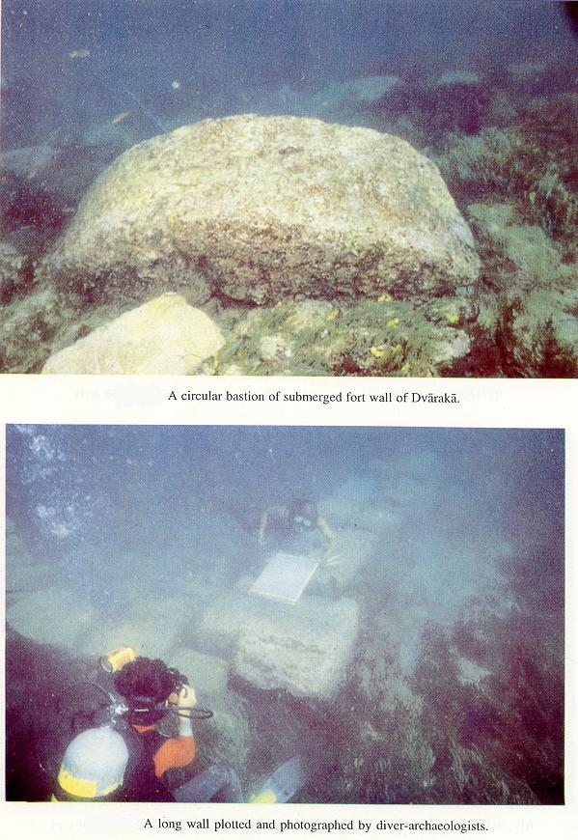

Nearly a decade ago, the Archaeological Survey of India discovered copper coins, fragments of granite structures, and pottery which suggests that the city could be 3,000 years old.
Mundos bajo el agua»  «Underwater Worlds» | 11 de noviembre de 2010 | 11 de noviembre de 2010

https://www.indianweekender.co.nz/Pages/ArticleDetails/51/1421/Comment/How-science-discovered-the-historical-Krishna
http://veda.wikidot.com/dwaraka

